**SETTING UP DEVELOPER ENVIRONMENT**

**1. SELECTING MY OPERATING SYSTEM (OS)**

* My operating system is Windows version 10 Pro.
* Due to fear of losing my sensitive work documents, I could not proceed with installing Windows 11.
* Therefore, I opted to proceed using Windows 10 Pro already installed on my laptop.

**2. INSTALLING TEXT EDITOR/INTEGRATED DEVELOPMENT ENVIRONMENT (IDE)**

* Proceed to open the download link for Visual Studio Code: <https://code.visualstudio.com/Download> and choose my operating system and version to download a compatible visual studio code for my laptop.

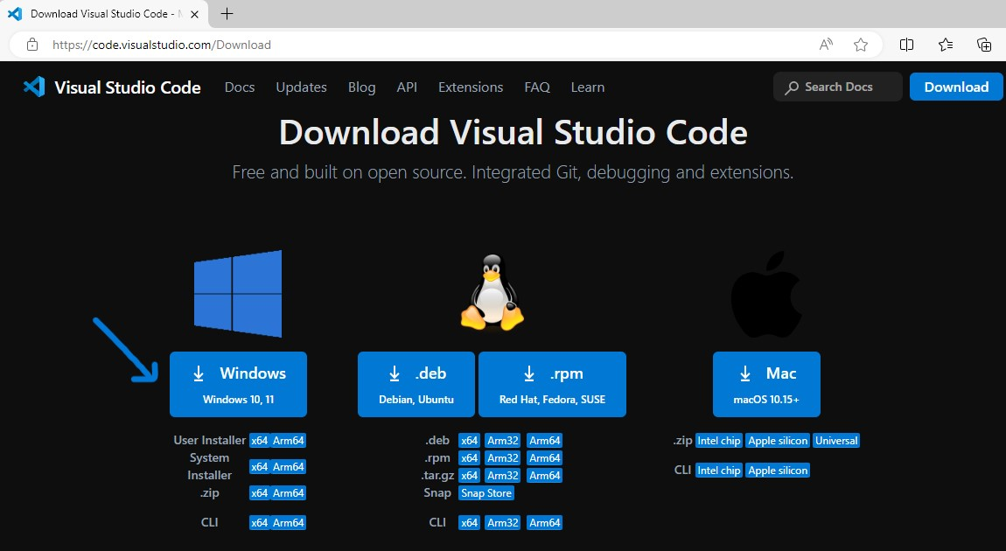

* Once I tap, it redirects me to a page where it initiates an automatic download process.

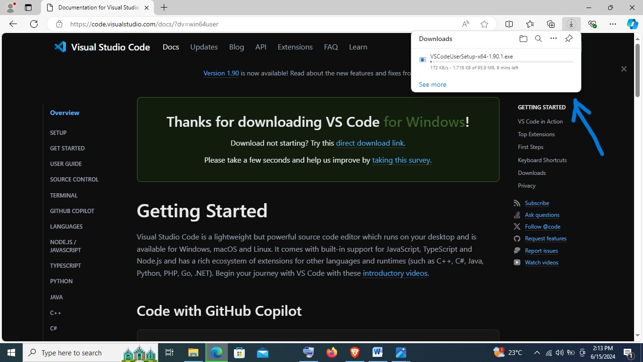

* Open the folder in which the visualstudio code is downloaded in and right click on the download and choose run as administrator.

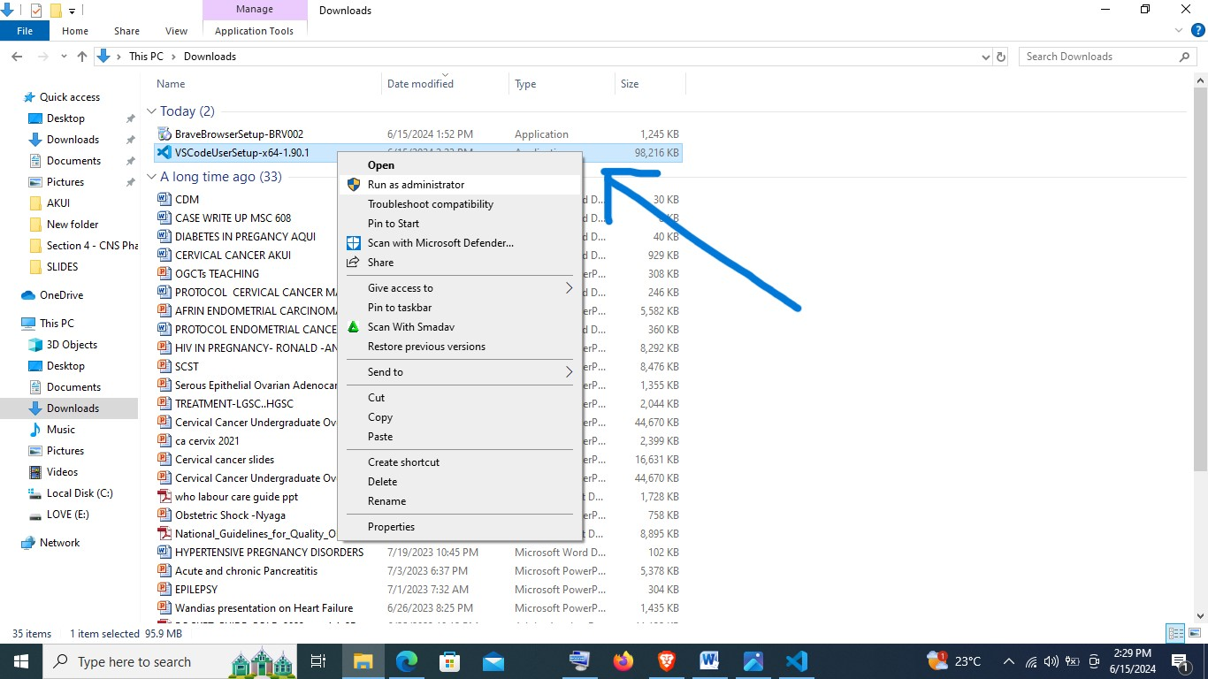

* Which will prompt the set-up and click on accept the agreement, and then click on next.

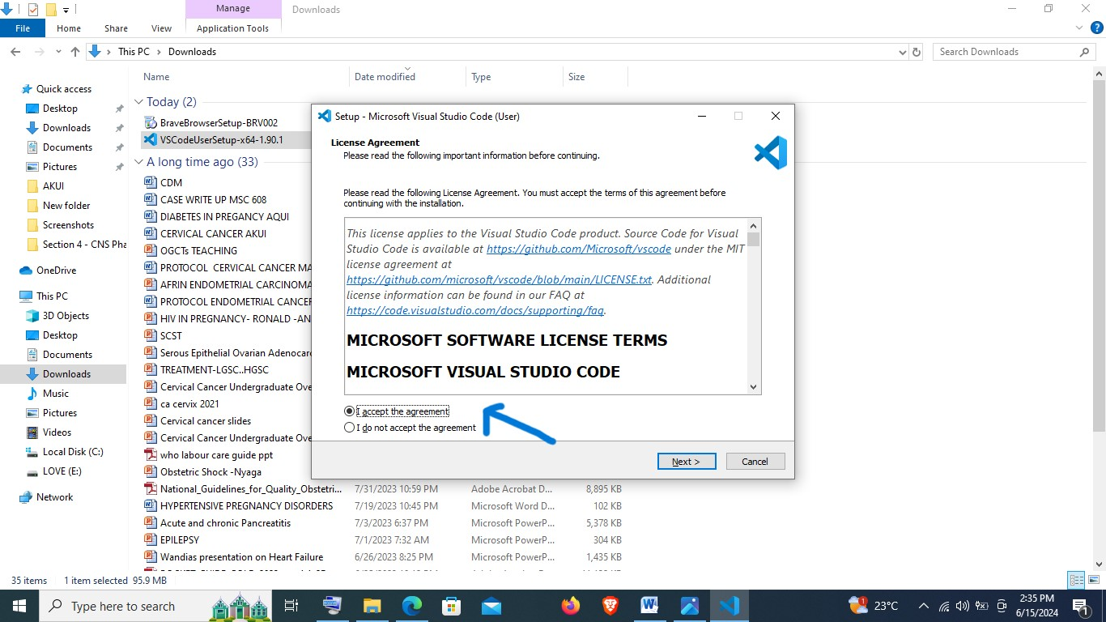

* Then proceed step by step as highlighted by the following images:

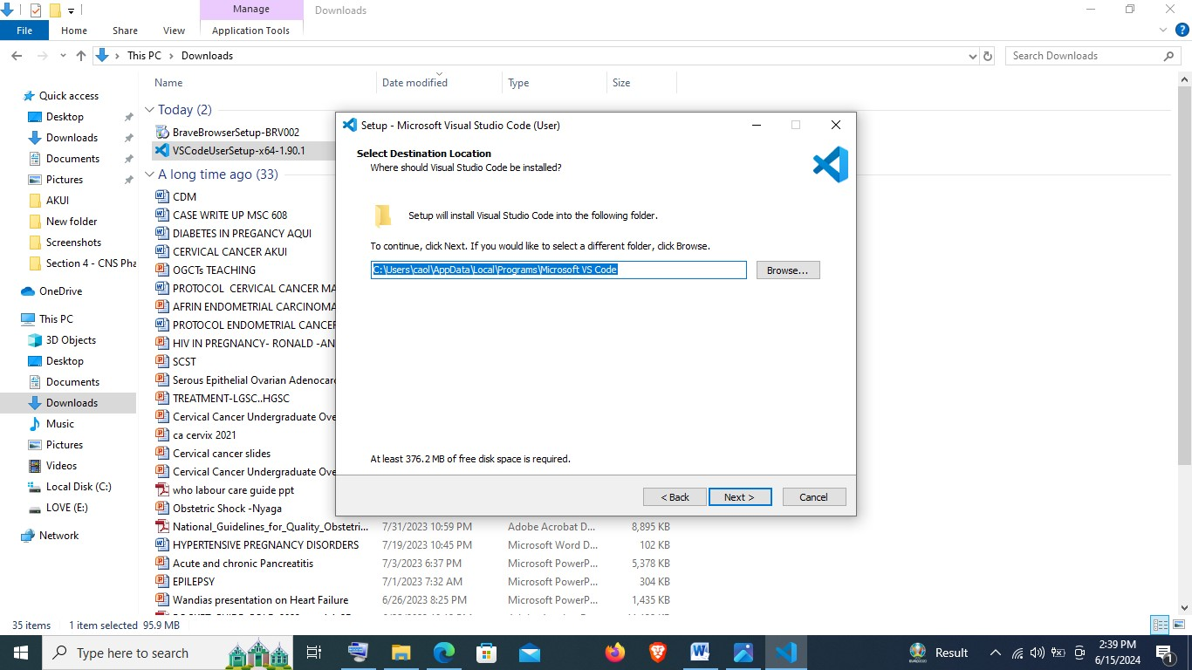

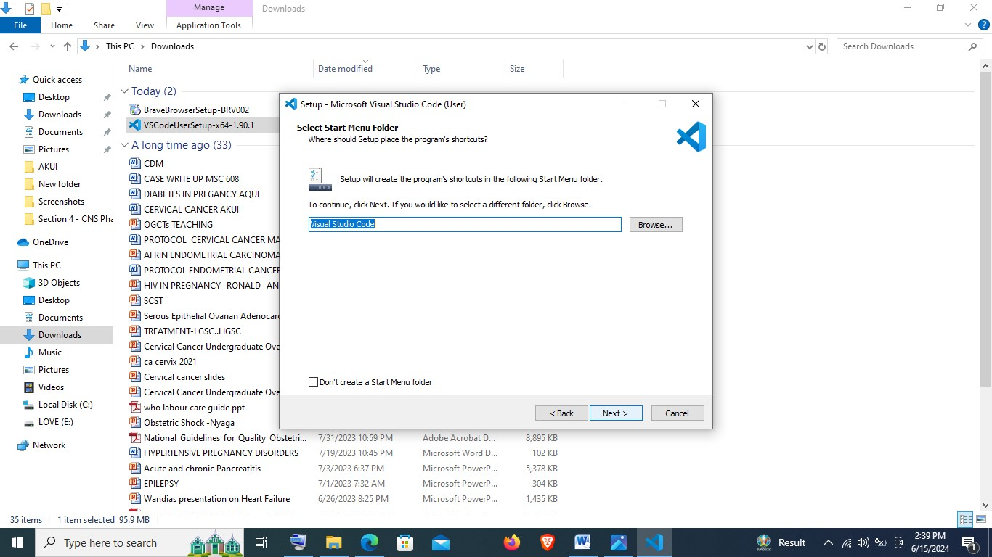

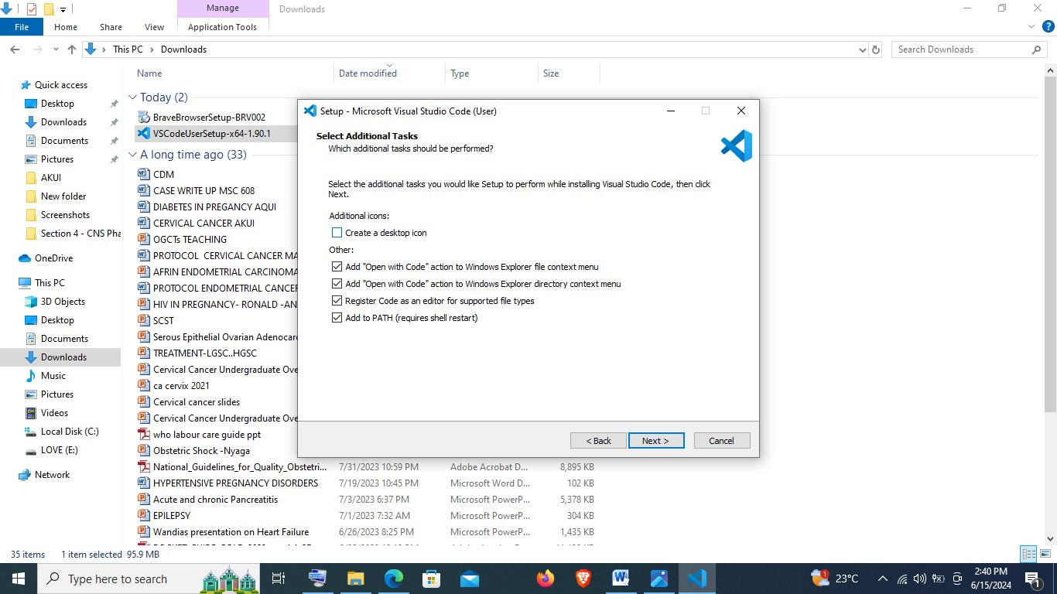

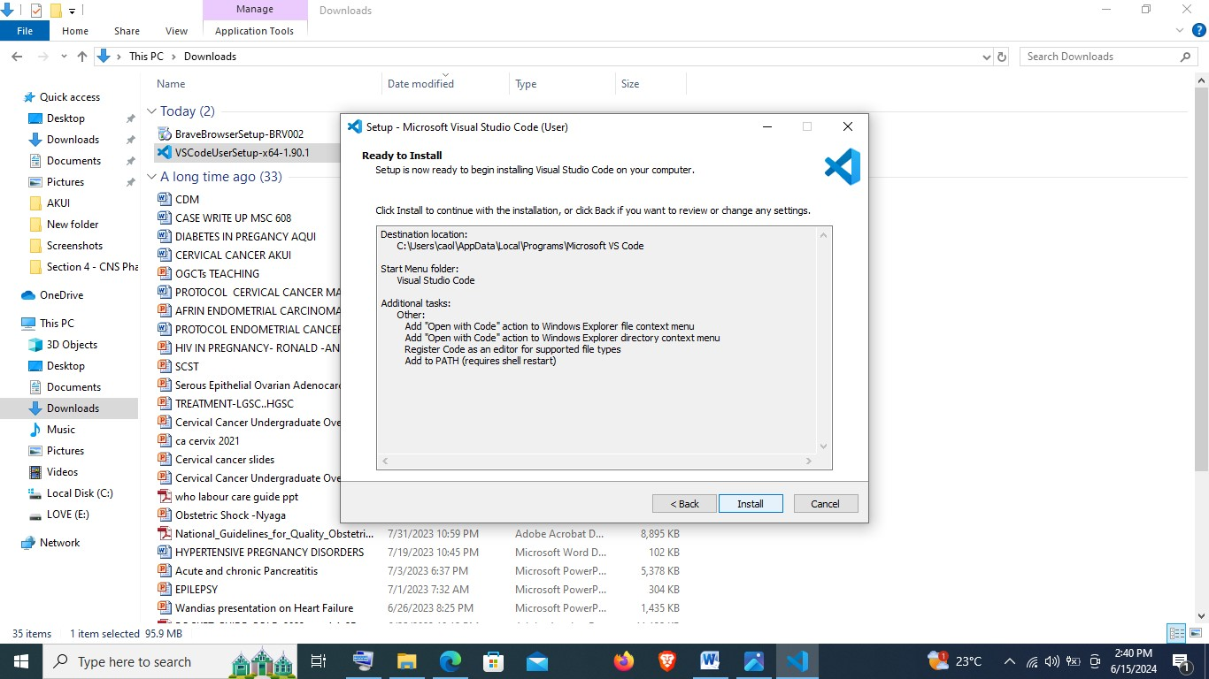

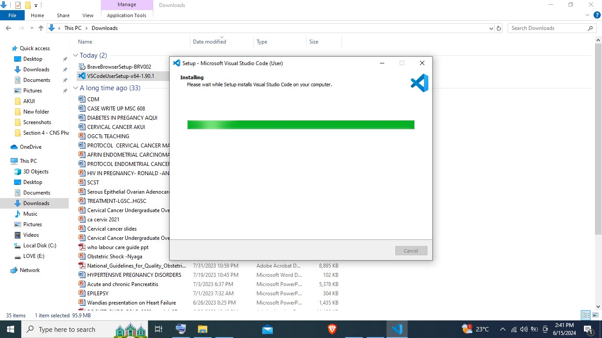

* Finally after installation, it will open visual studio code, allowing for more exploration.

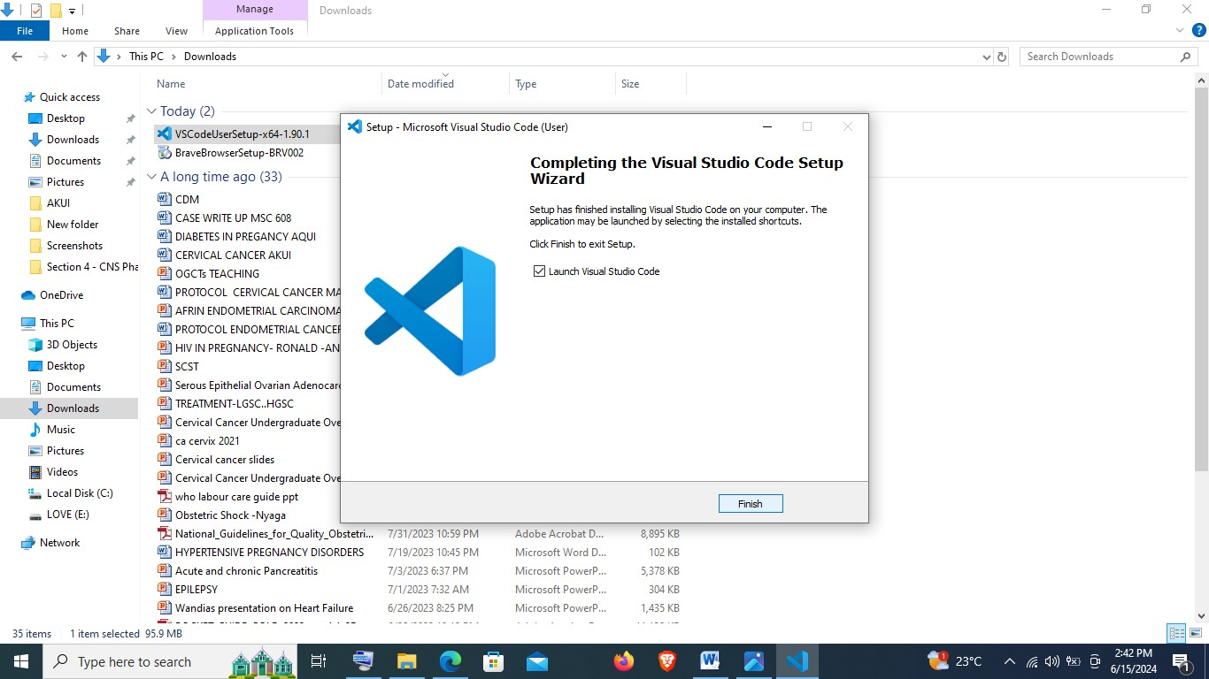

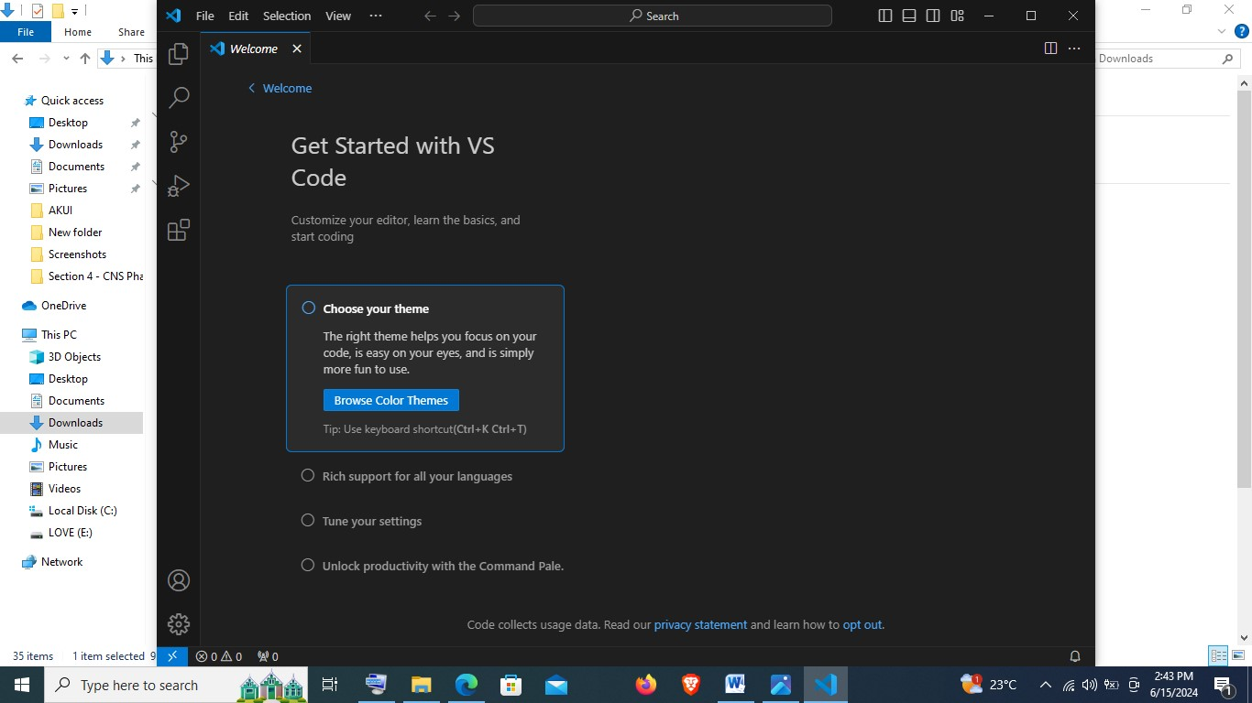

**3. SETTING UP VERSION CONTROL SYSTEM (VCS)**

**Installing and configuring Git**

* Open the following link: [Git - Downloads (git-scm.com)](https://git-scm.com/downloads) to open the following site and choose my operating system and version to download a compatible Git for my laptop.

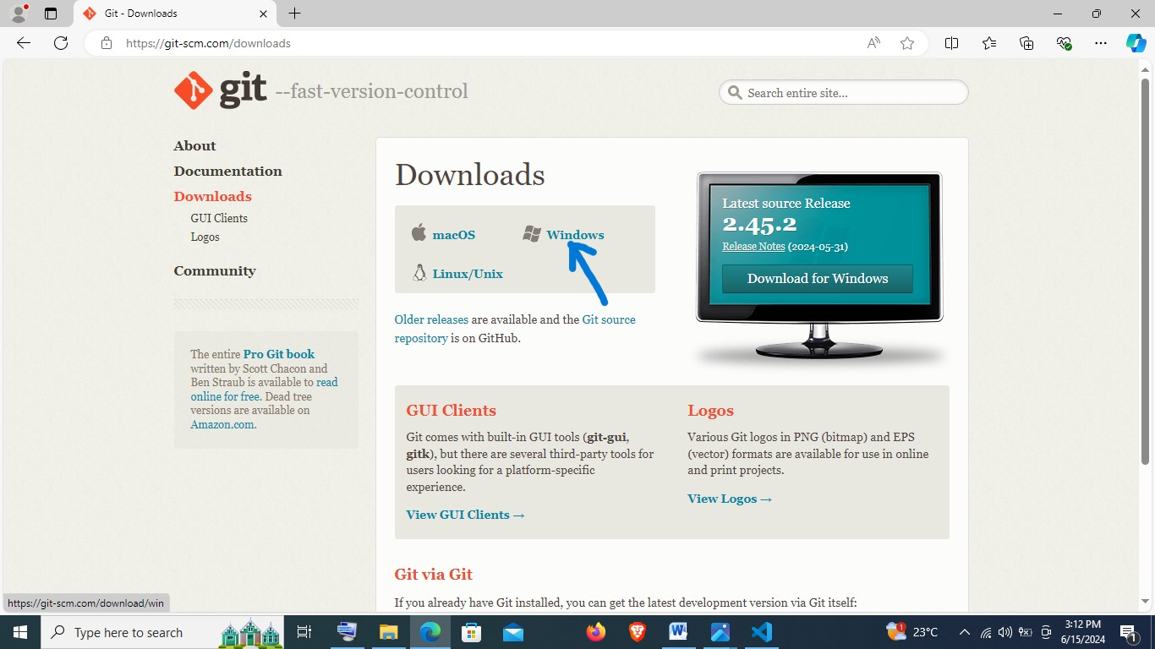

* Then I choose the build of my system, which in my case is a **64 bit system**.

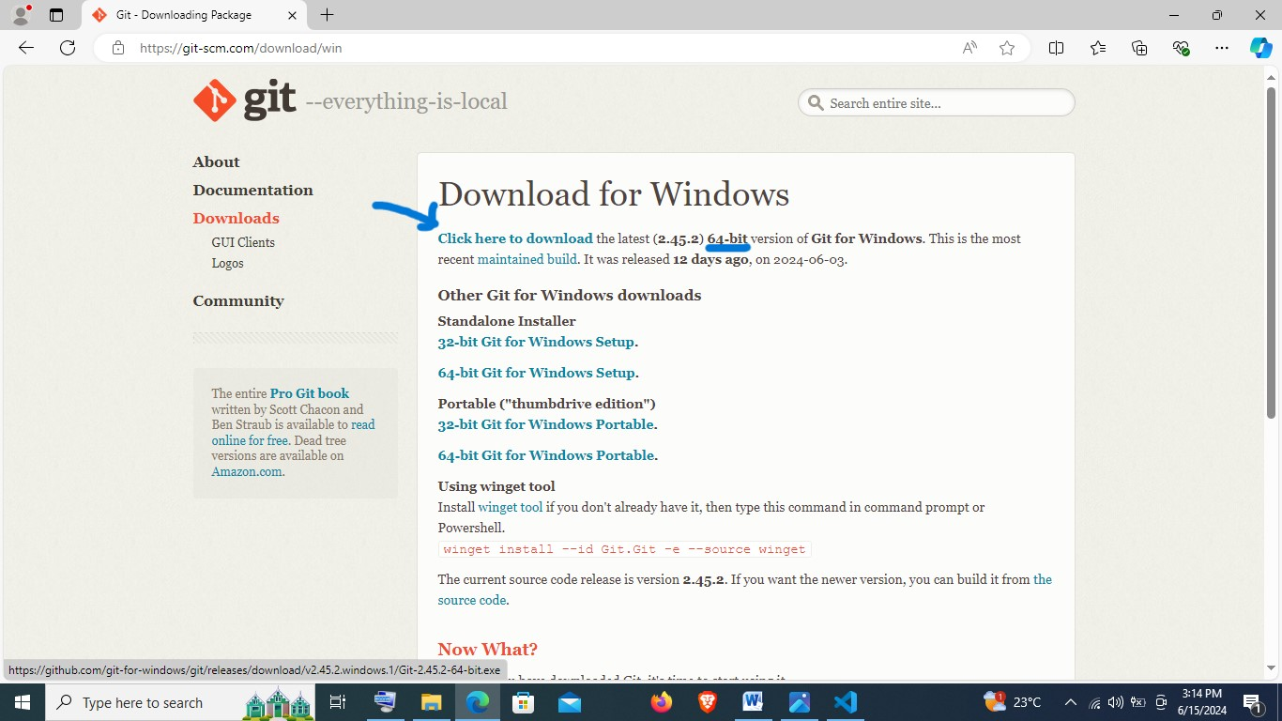

* Once I tap, it redirects me to a page where it initiates an automatic download process.

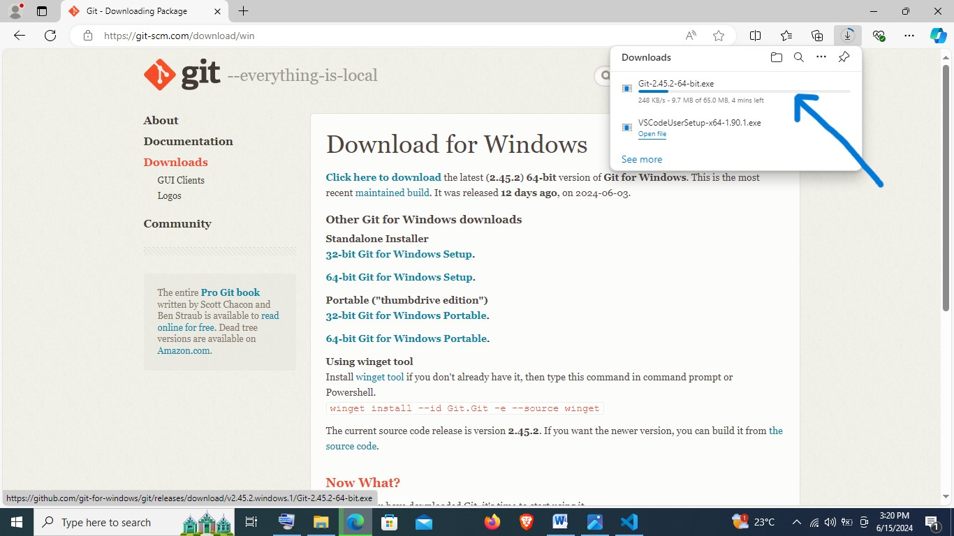

* Open the folder in which the Git is downloaded in and right click on the download and choose run as administrator.

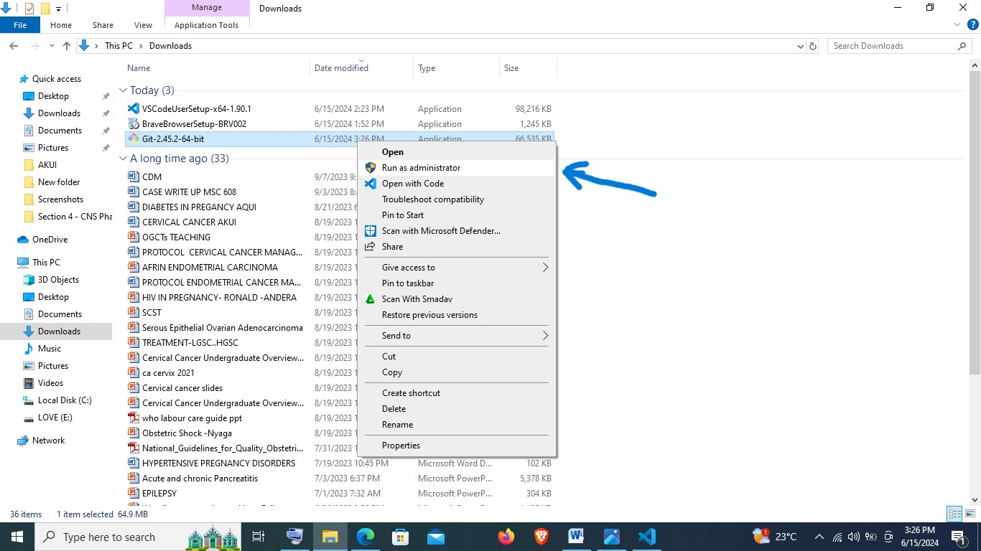

* Then follow the following steps as demonstrated by the following images:

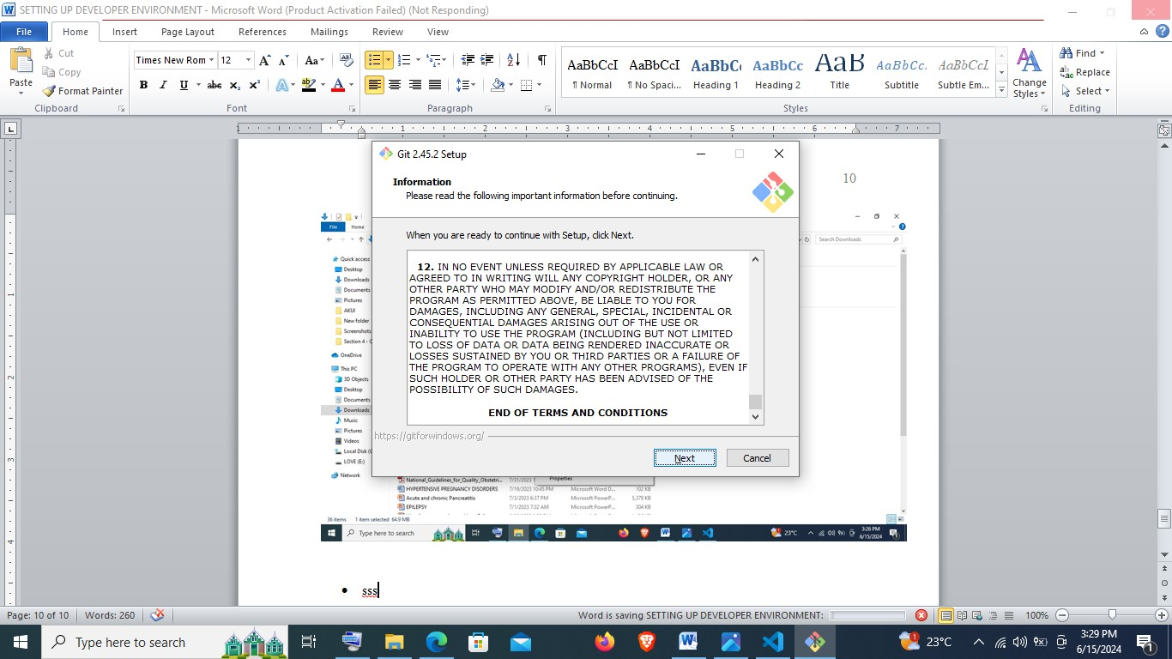

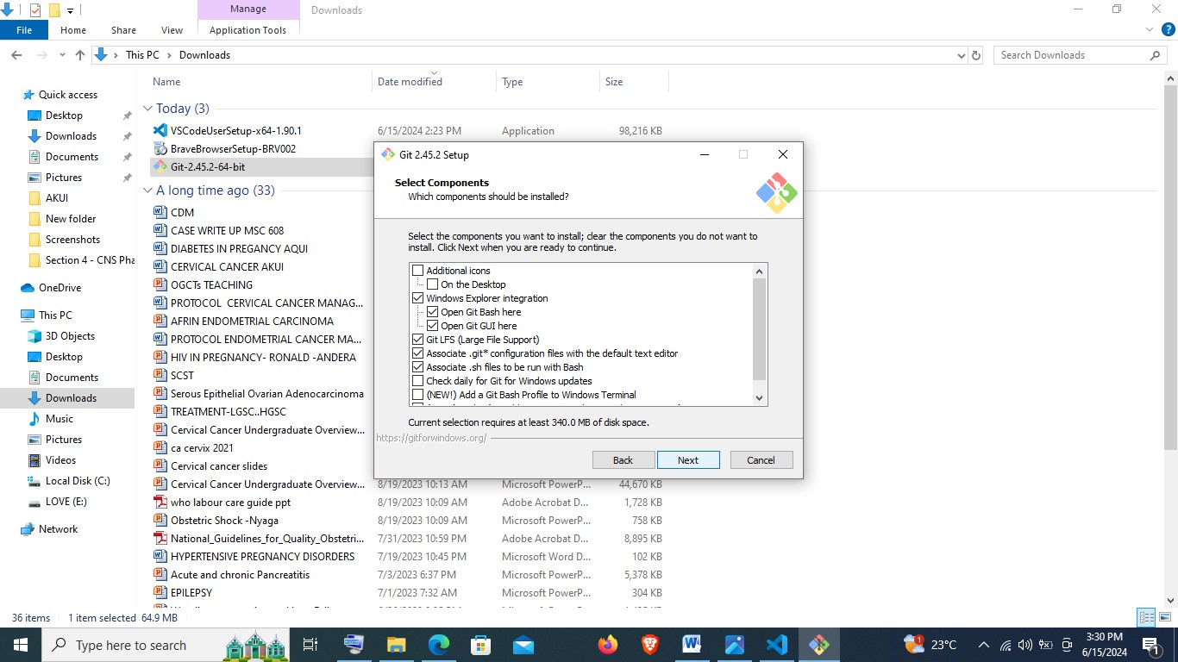

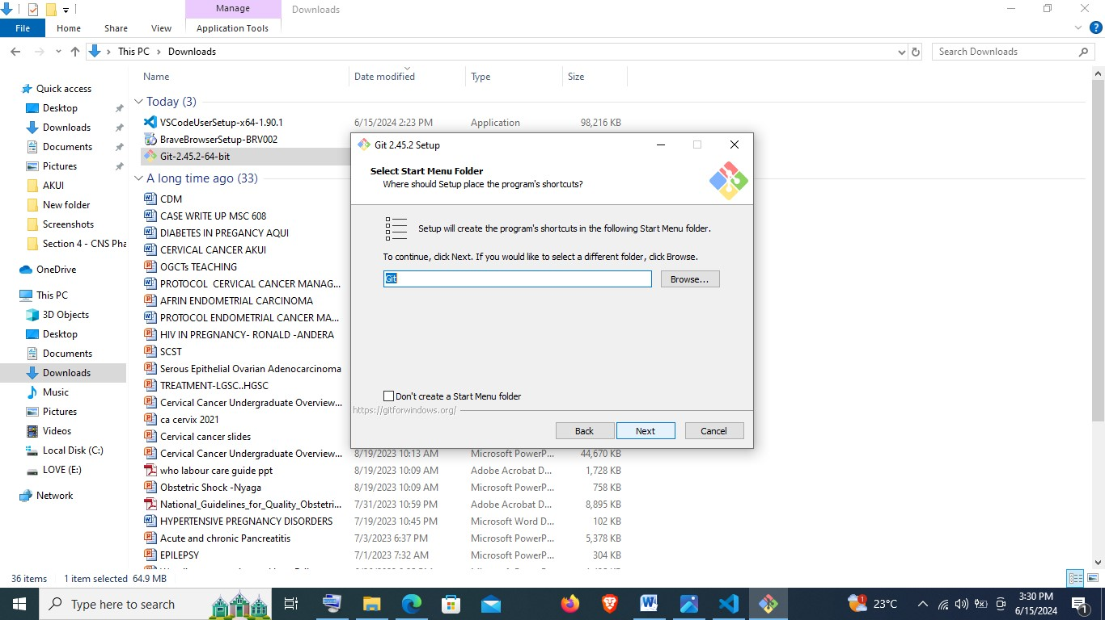

**NB:** given that I have installed Visual Studio Code, I will set it as my default editor as demonstrated below:

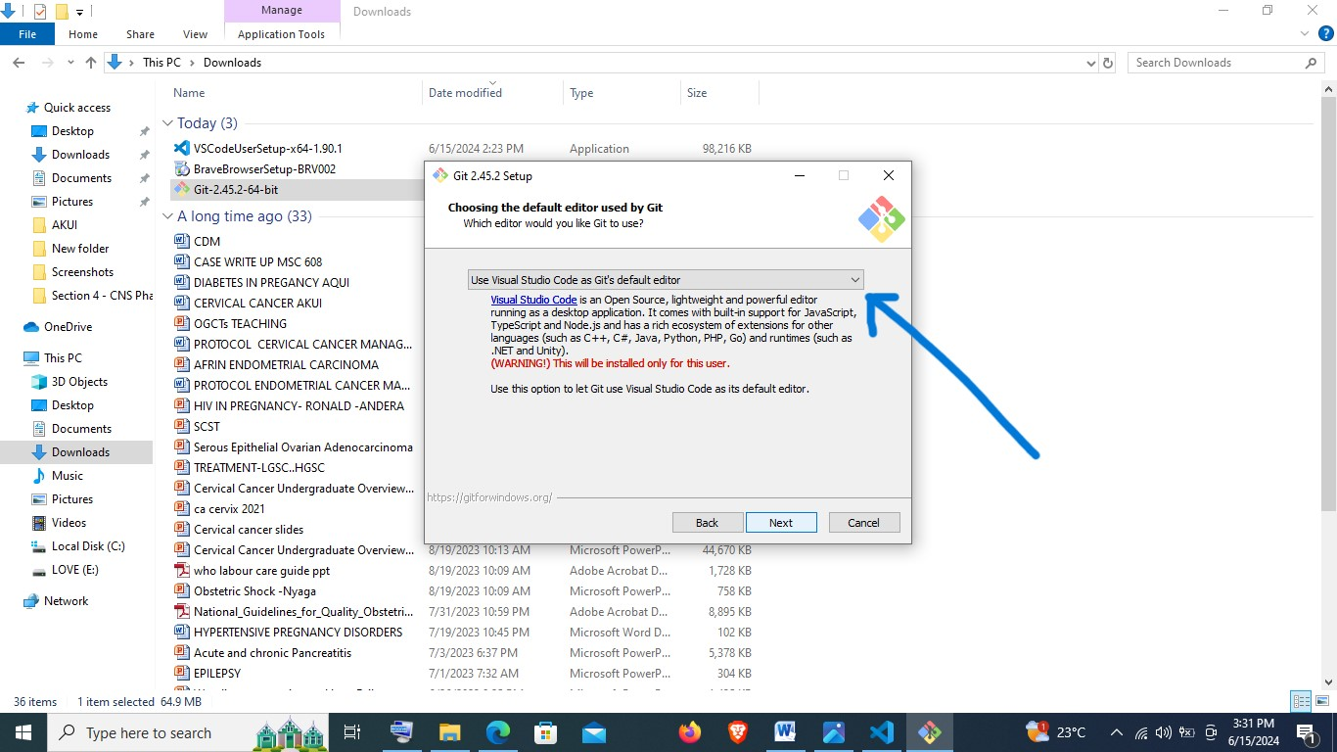

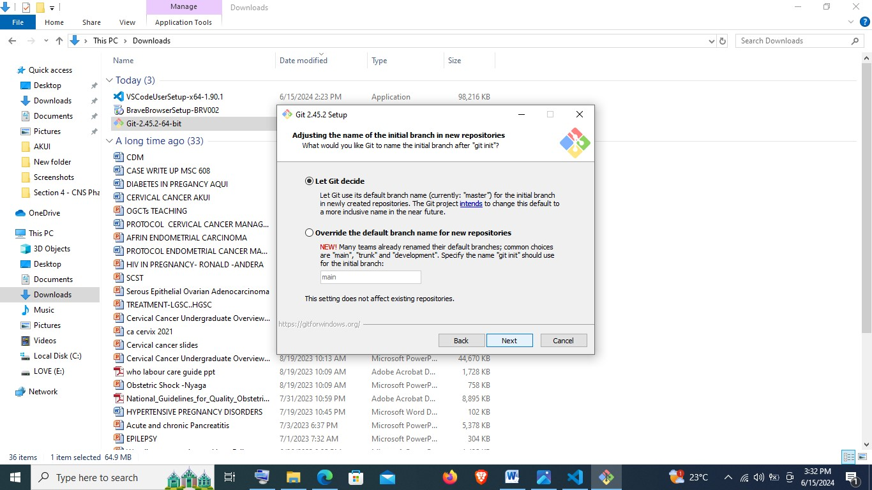

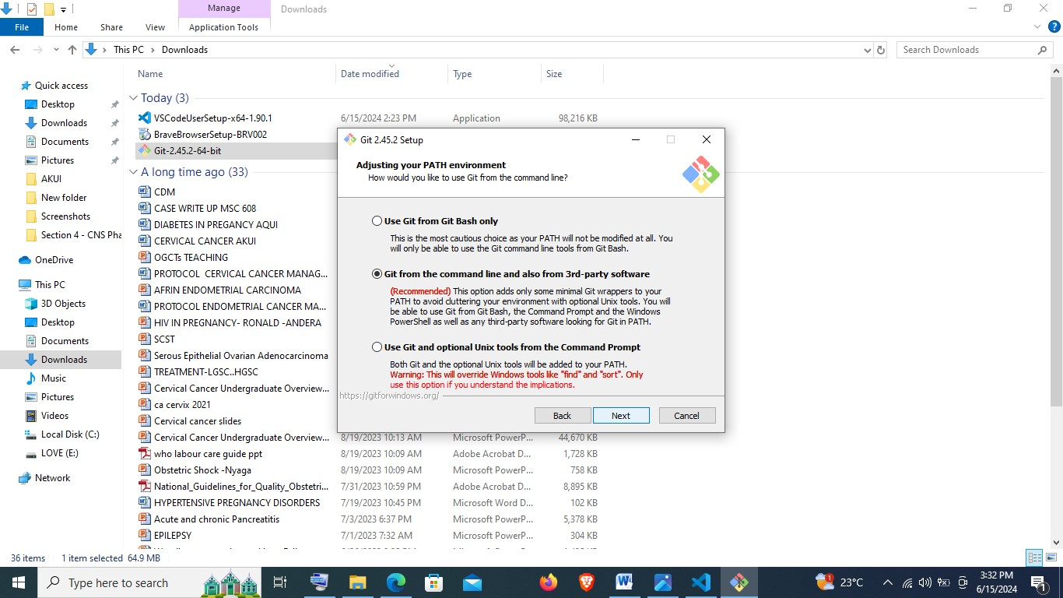

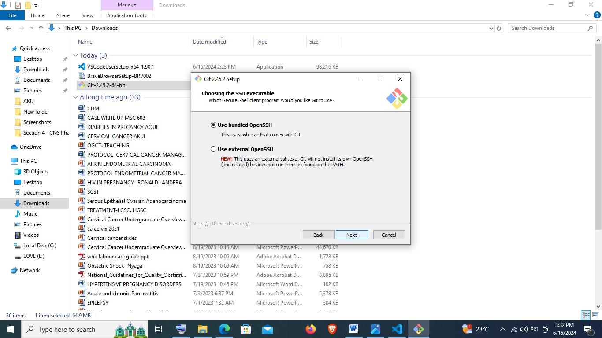

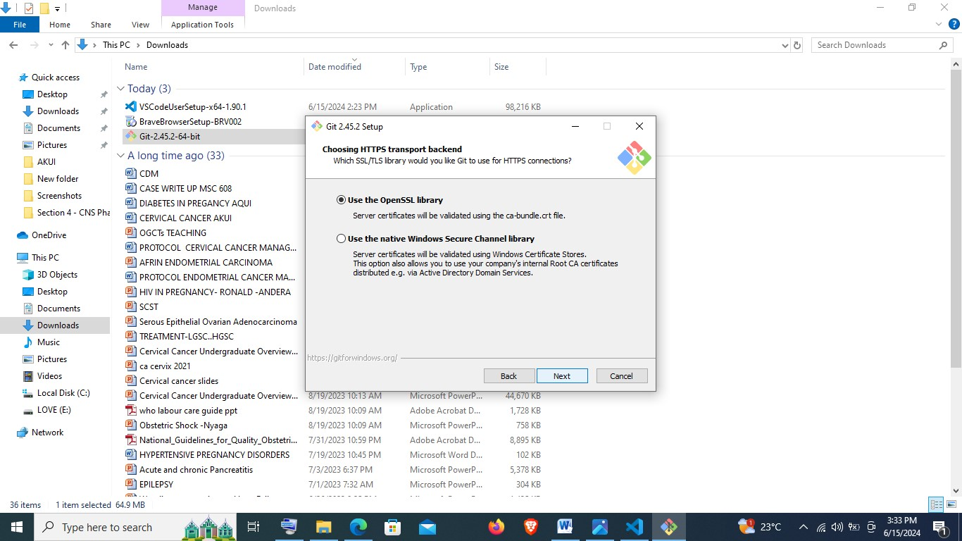

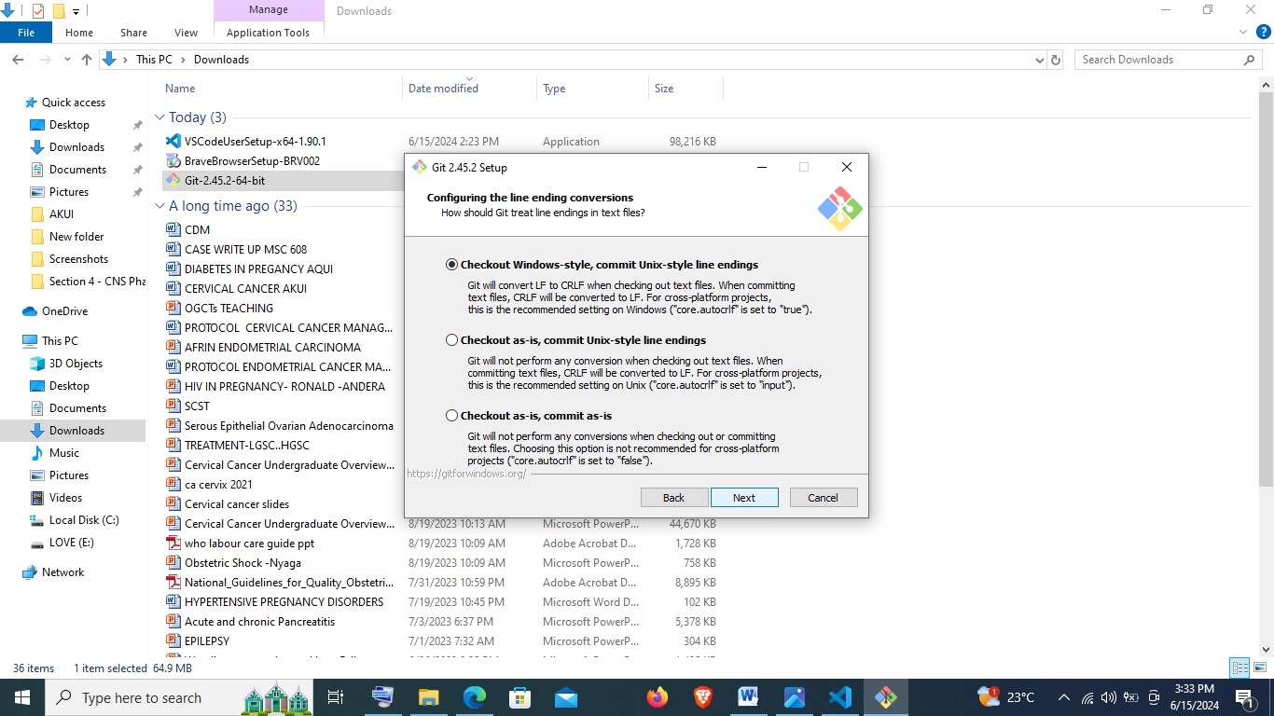

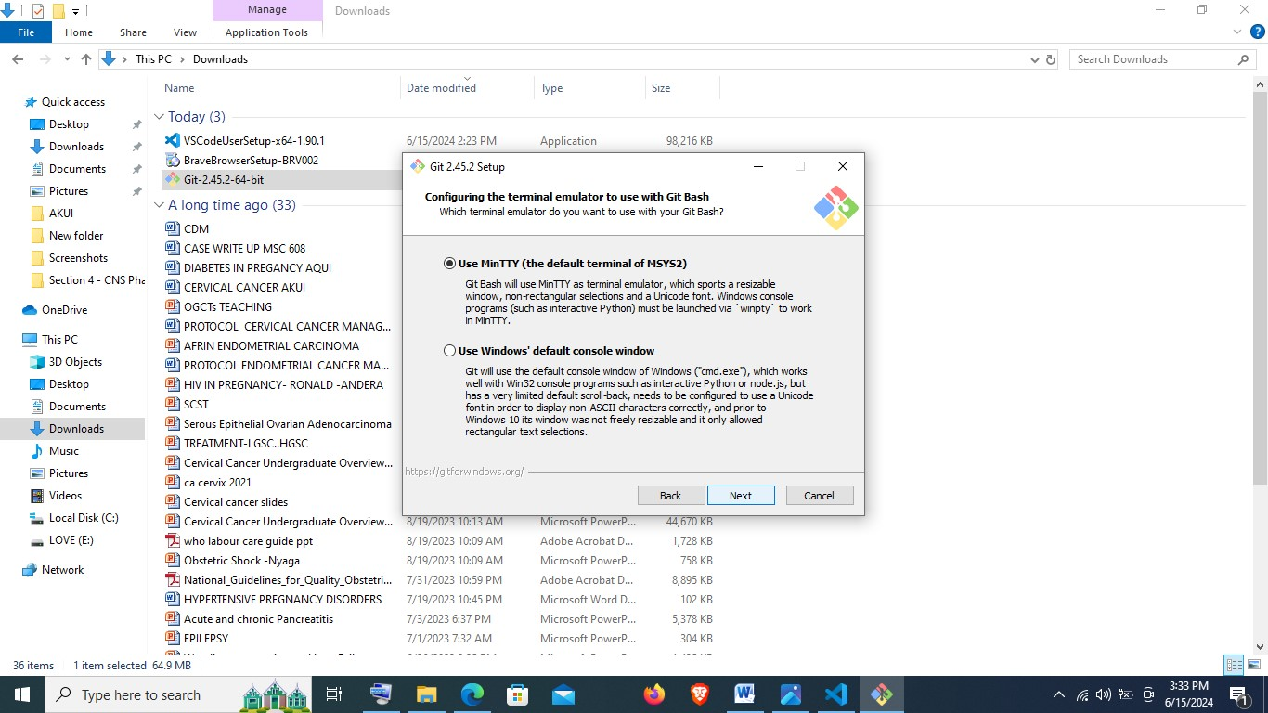

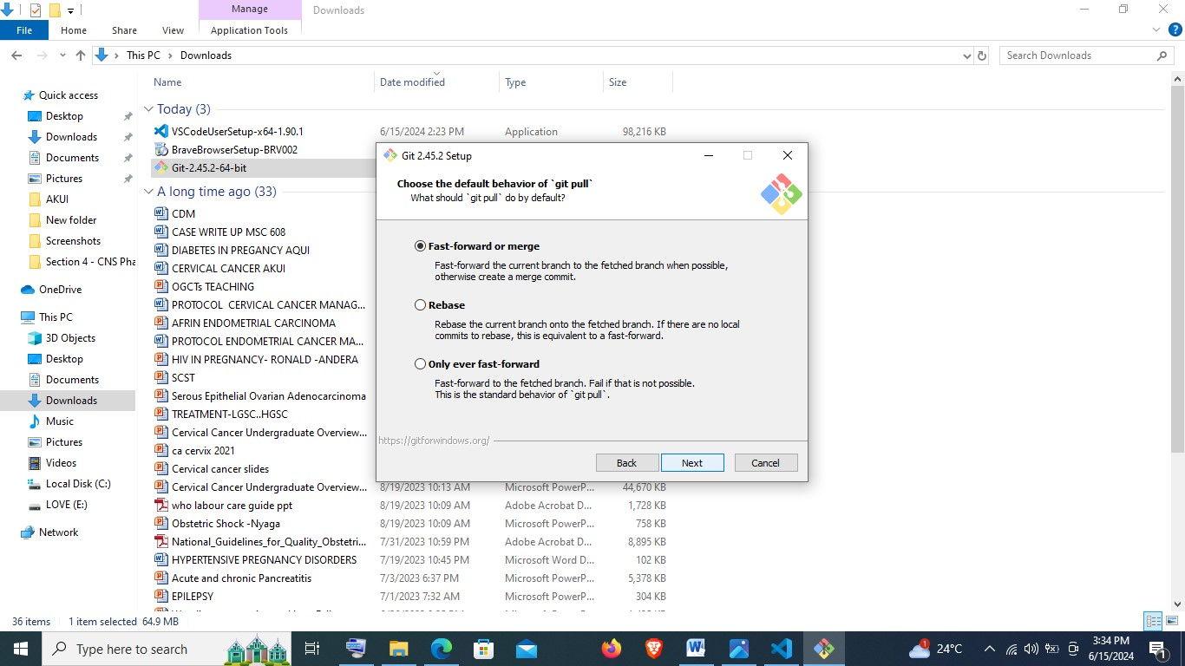

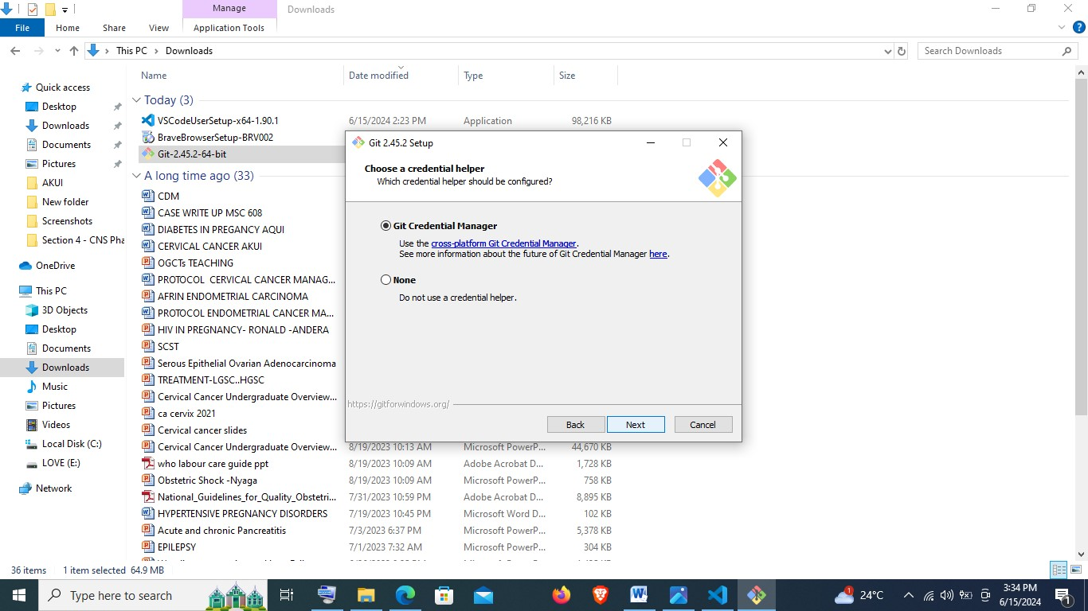

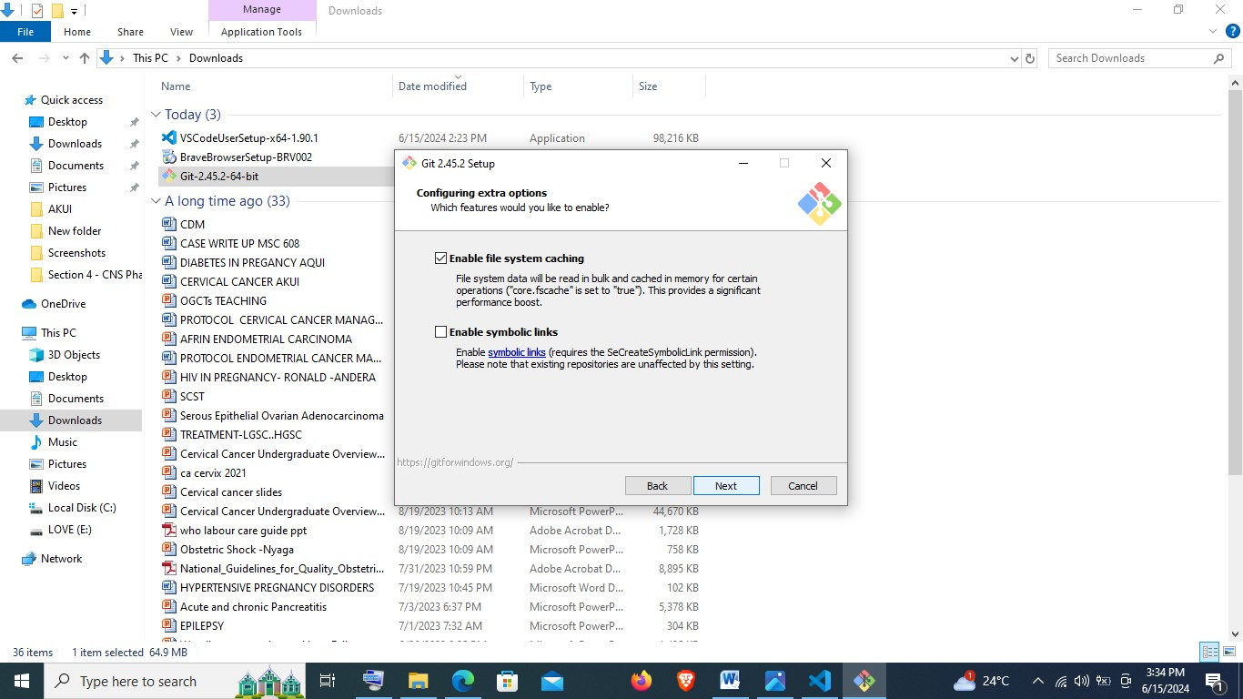

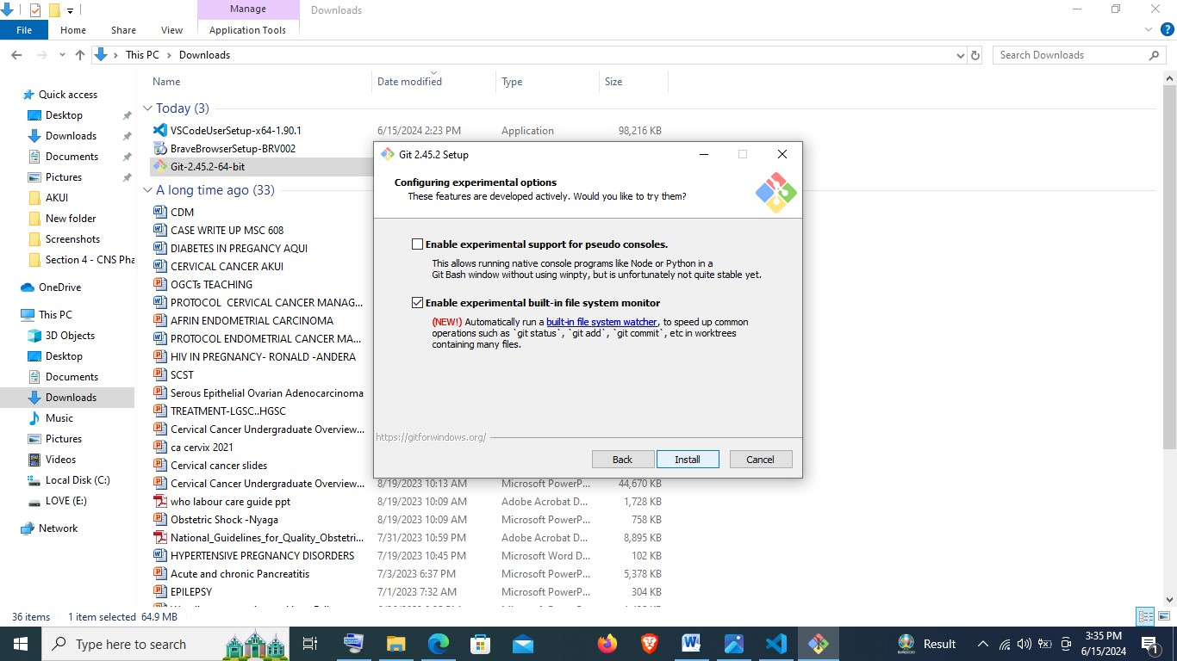

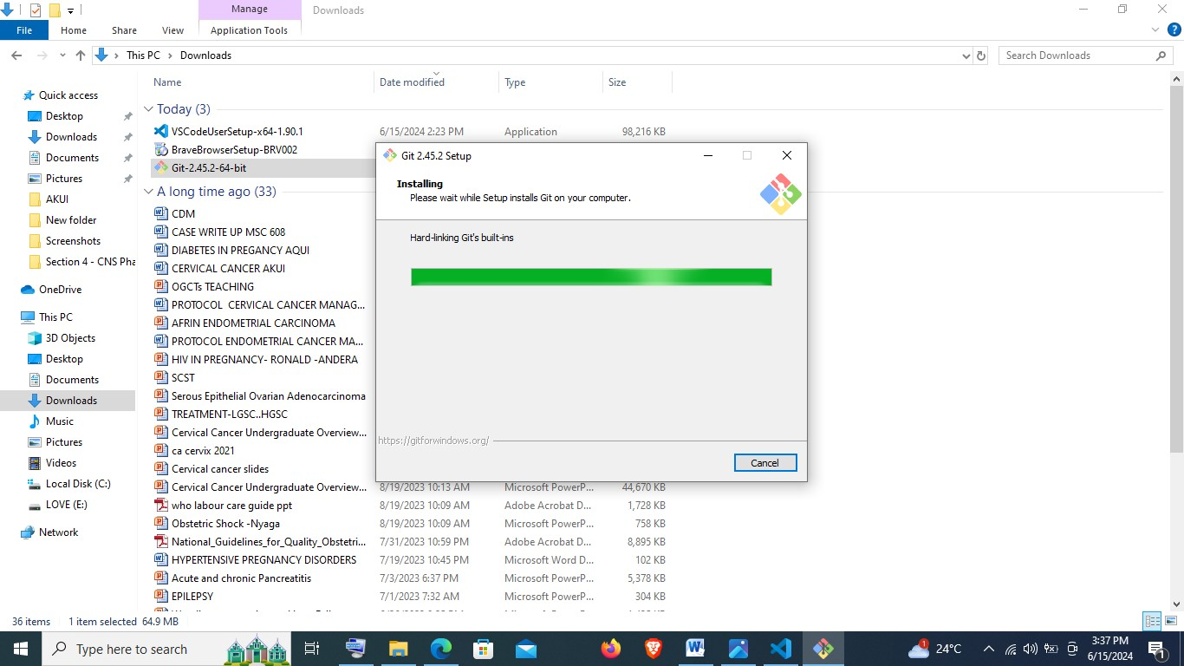

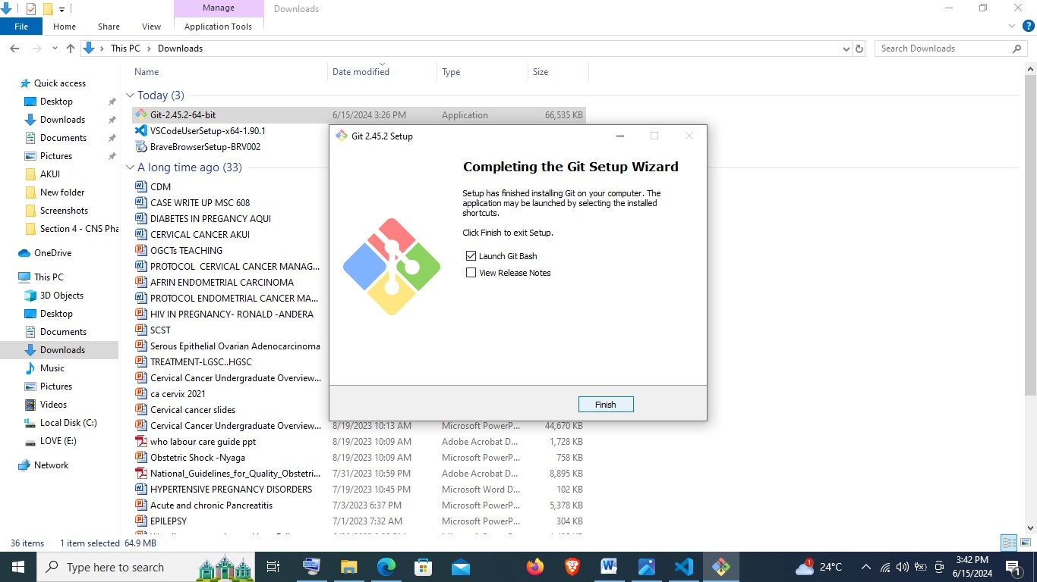

* Finally after installation, click on finish prompting Gitbash to launch.

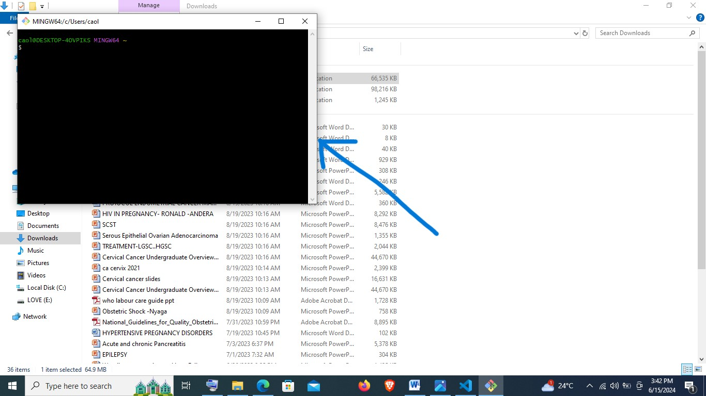

* I will confirm that it works by typing: **git - -version**

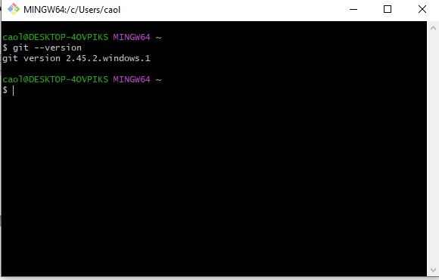

**Creating a GitHub Account**

* Open the following link: <https://github.com> and click on **sign up**

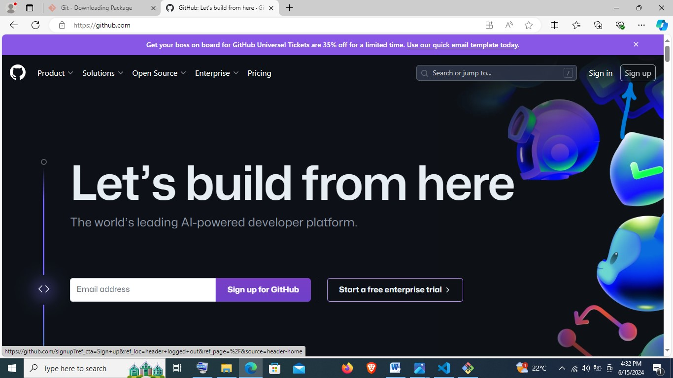

* Key in the required details for signing up as follows:

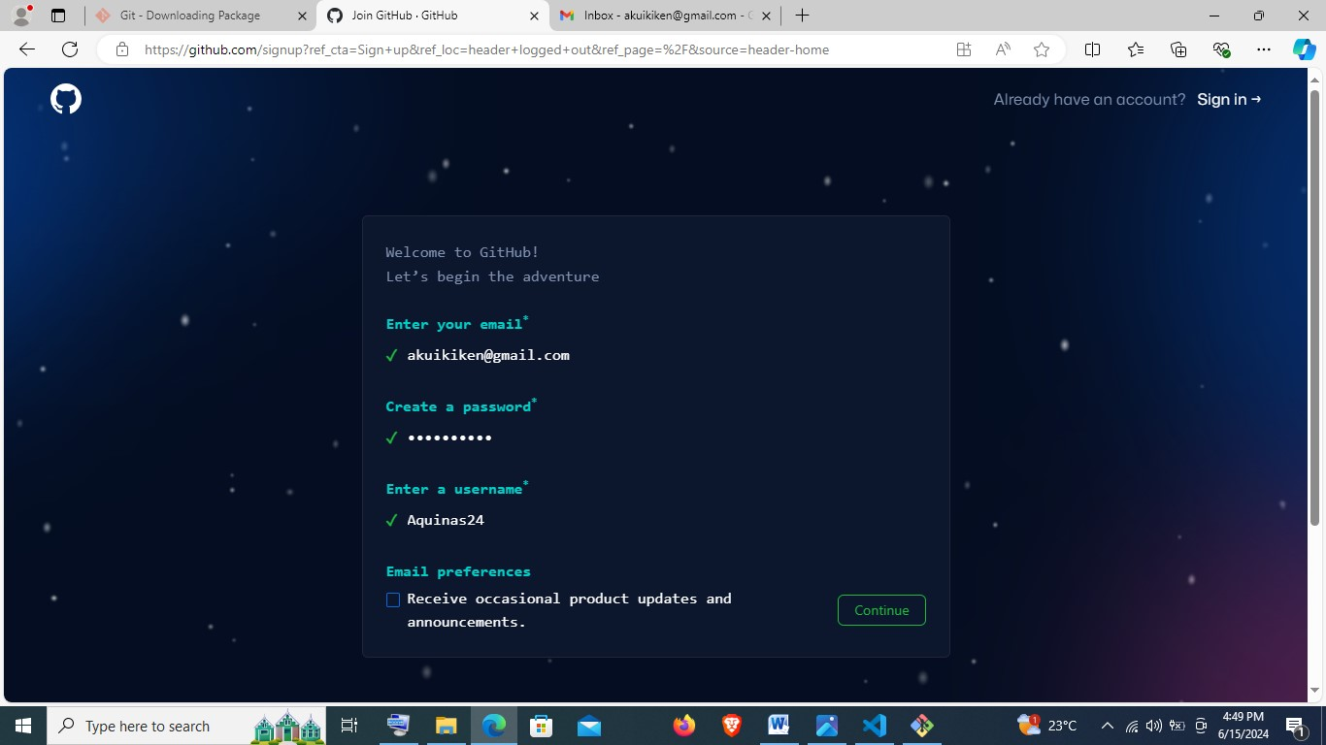

Then confirm email and sign in:

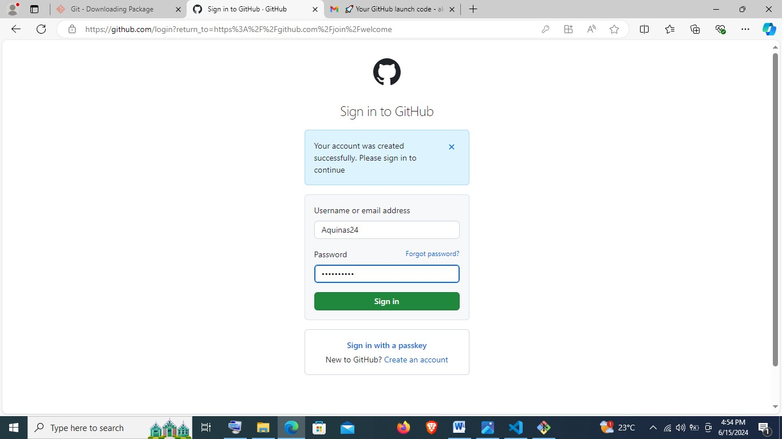

Once signed in, it will appear as below:

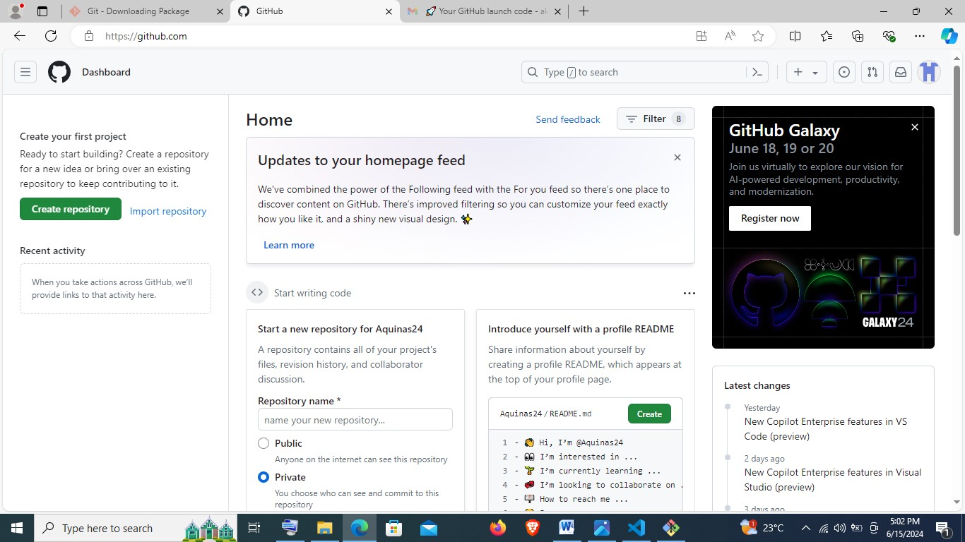

**Linking Git and GitHub**

* Open Gitbash and type the following:

To configure my GitHub username and email:

* git config - - global user.name “Aquinas24”
* git config - - global user.email [akuikiken@gmail.com](mailto:akuikiken@gmail.com)

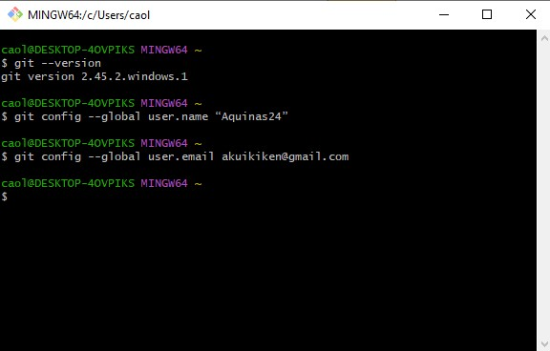

* Proceed to creating a local repository in the following steps:
* **cd e:/** to open the drive where I will create my repository.
* **mkdir DEMO** to create a new directory called **DEMO** that will contain my local repository.
* **cd DEMO** to open the directory.
* **git init** to initialize a local git repository in the **DEMO** directory.

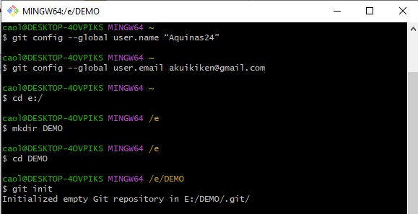

* **vi Repository.txt** to create a new file, which I can insert text by typing **i** and then close by pressing **escape, shift+colon, w, then q.**
* **vi README.md** to create a markdown file, which I can insert text by typing **i** and then close by pressing **escape, shift+colon, w, then q.**
* **git add .** to add the **Repository.txt** and **README.md**  file to git.
* **git commit –m “first commit”** to save the file on git.

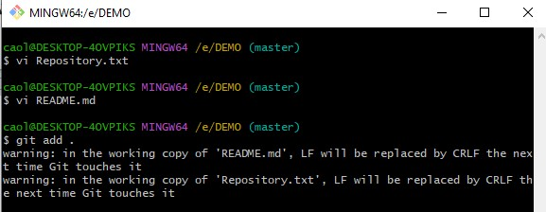

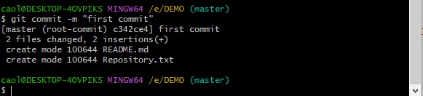

* Proceed to GitHub portal and create a new repository:

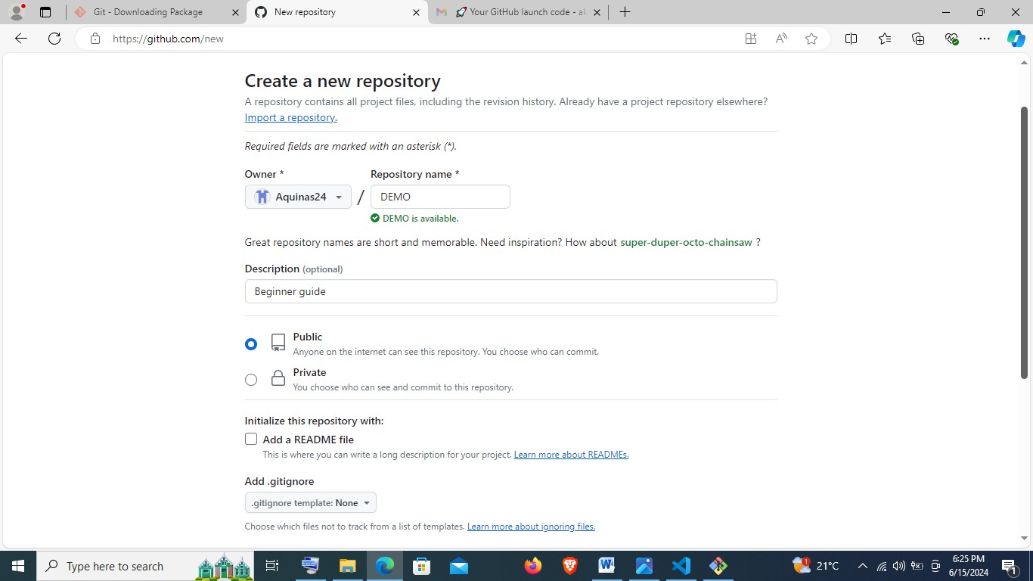

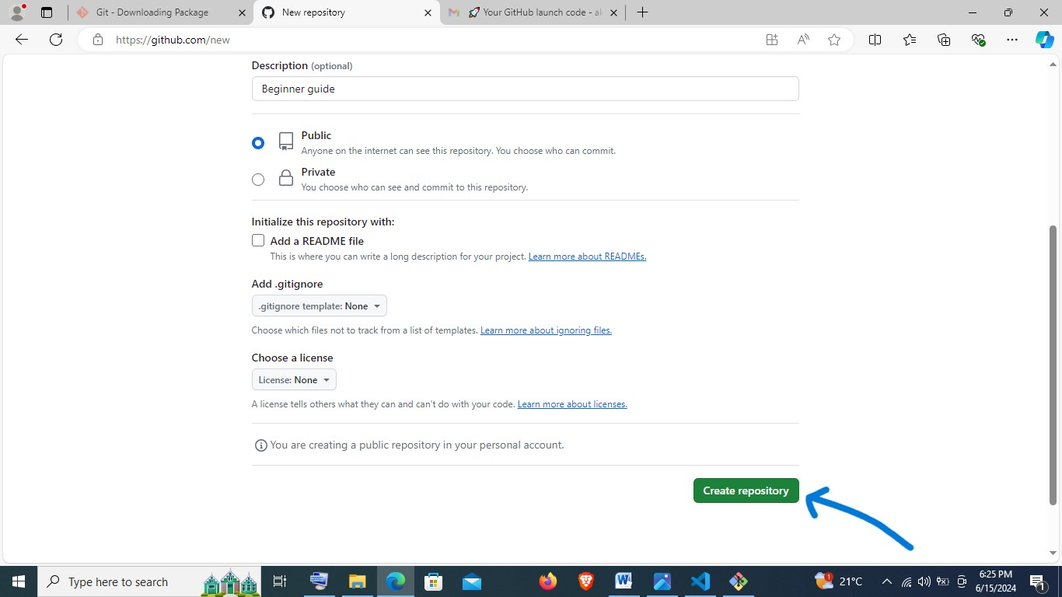

Copy the url in the empty repository as shown below:

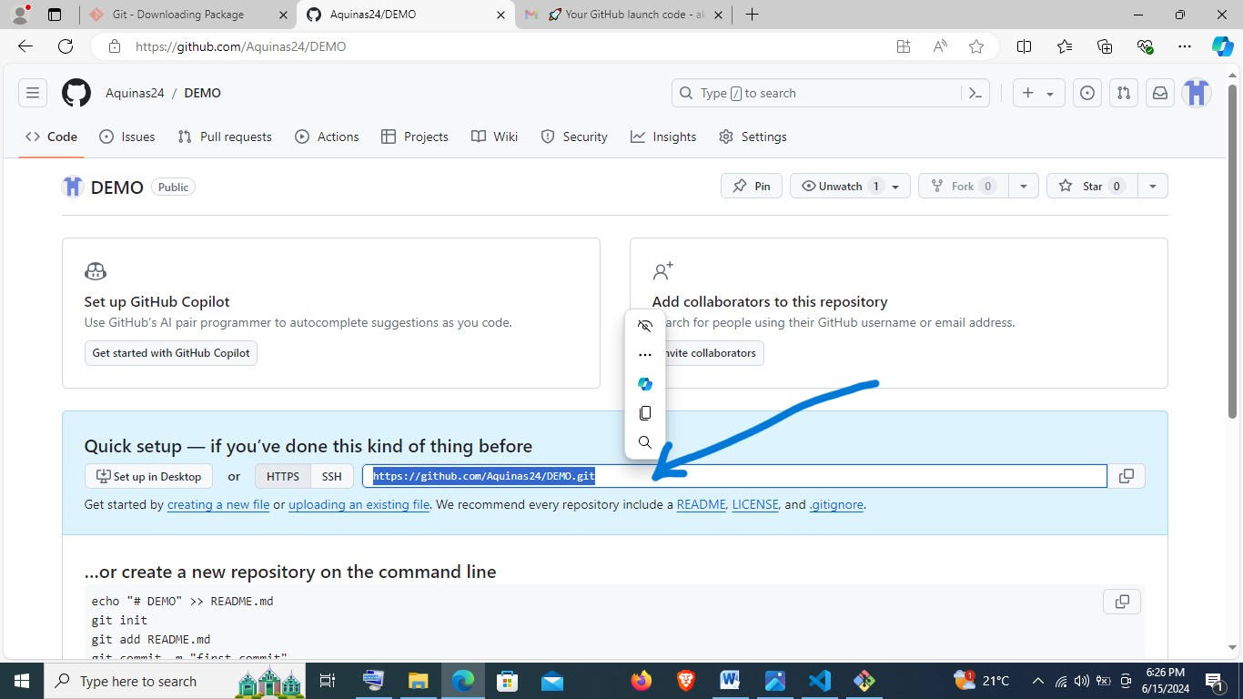

* Open Gitbash, and type the following:
* **git remote add origin** [**https://github.com/Aquinas24/DEMO.git**](https://github.com/Aquinas24/DEMO.git)
* **NB:** [**https://github.com/Aquinas24/DEMO.git**](https://github.com/Aquinas24/DEMO.git)is the link copied from the empty repository.

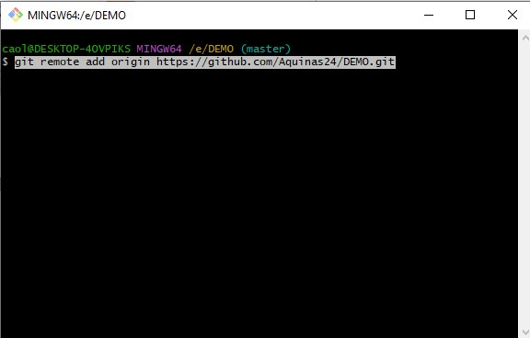

* Then proceed to type **git push -u origin master** given that my branch is master.
* This will prompt opening GitHub portal for signing in.

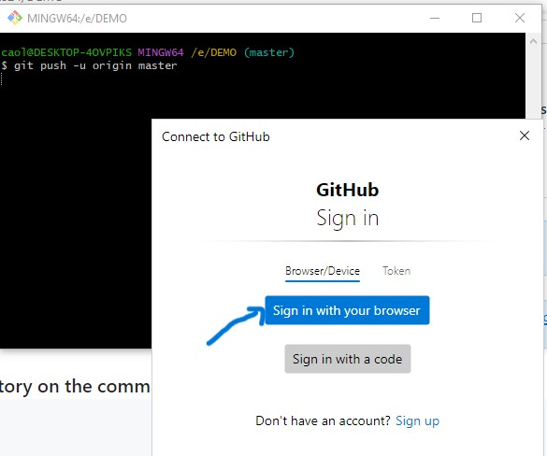

Proceed to authorize as follows:

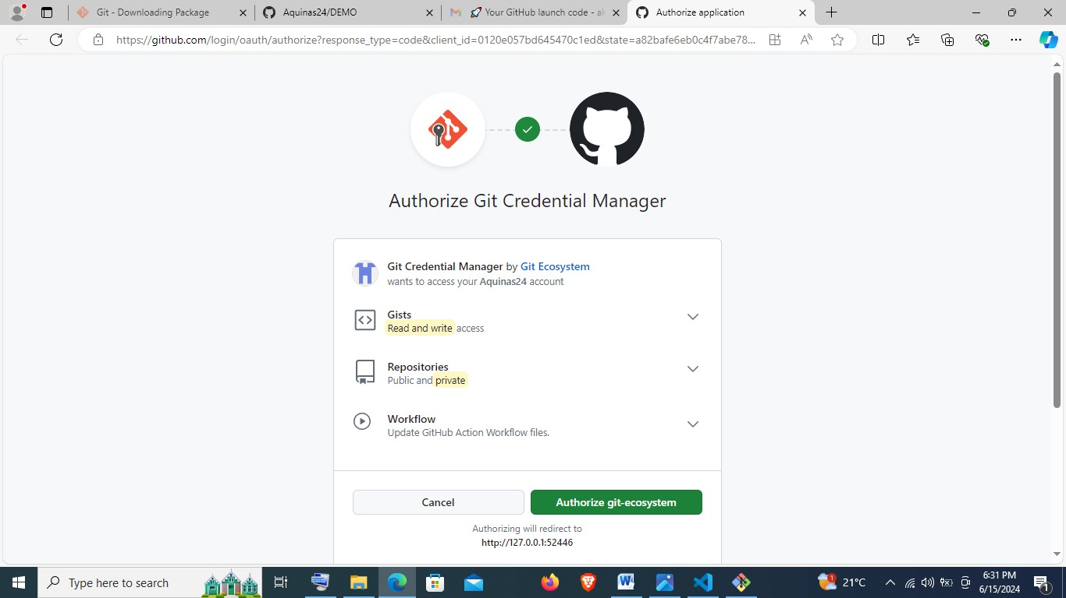

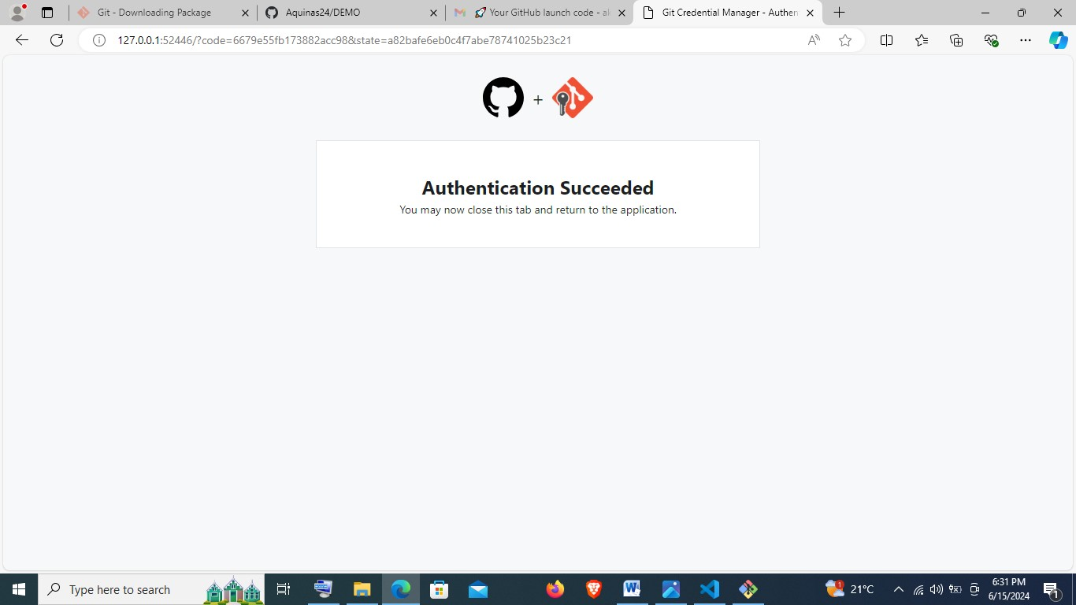

Back in Gitbash when the process is complete, it will show as below:

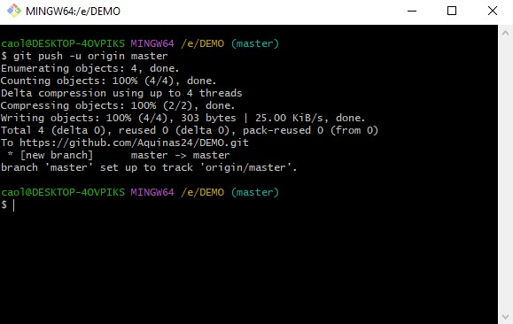

Refresh GitHub portal to observe the changes:

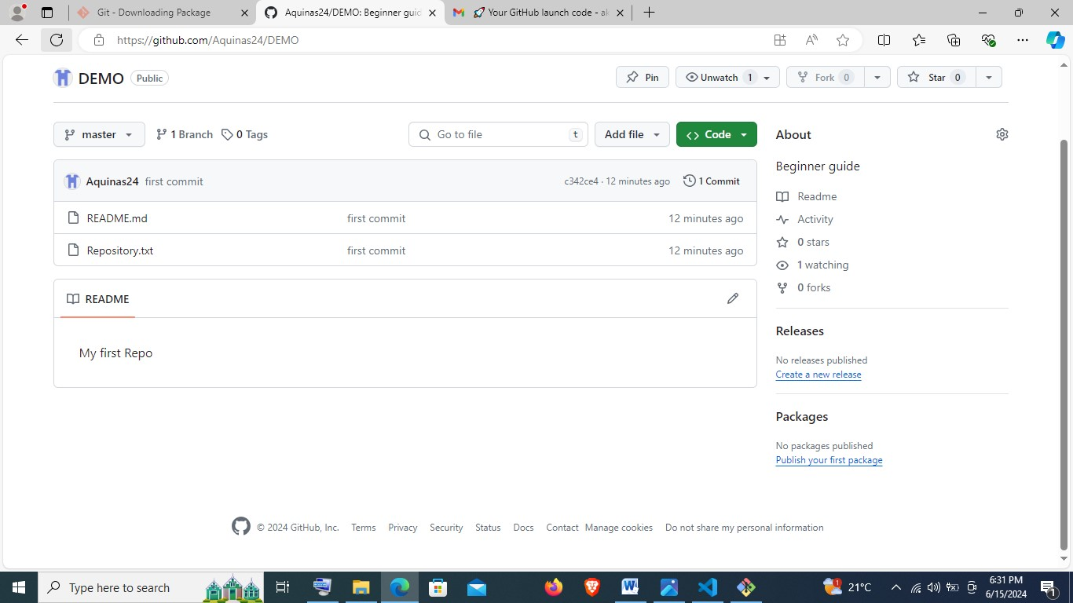

Type **code .** in Gitbash to view the contents on visual studio code:

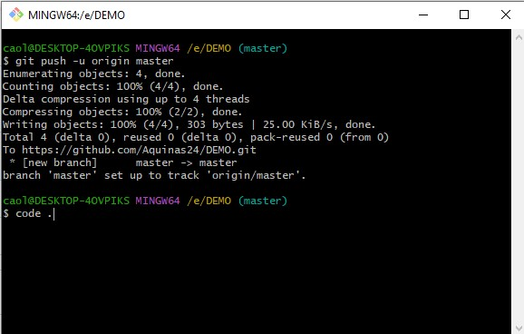

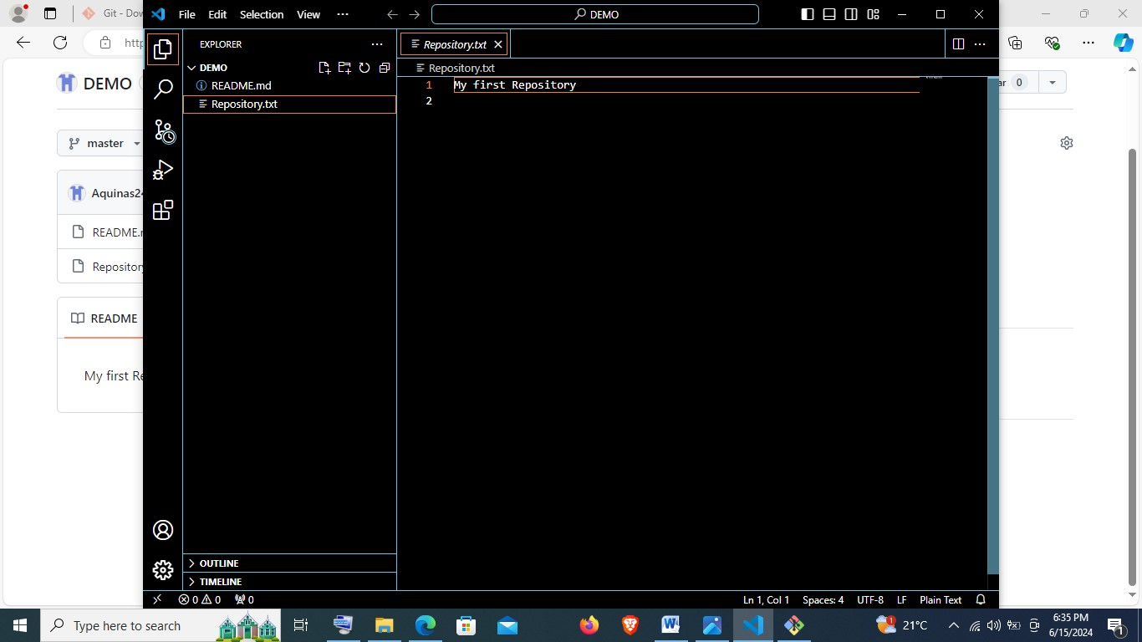

**4. INSTALLING PYTHON**

* Open the following link: <https://www.python.org> to open the following site and choose my operating system and version to download a compatible Python for my laptop.

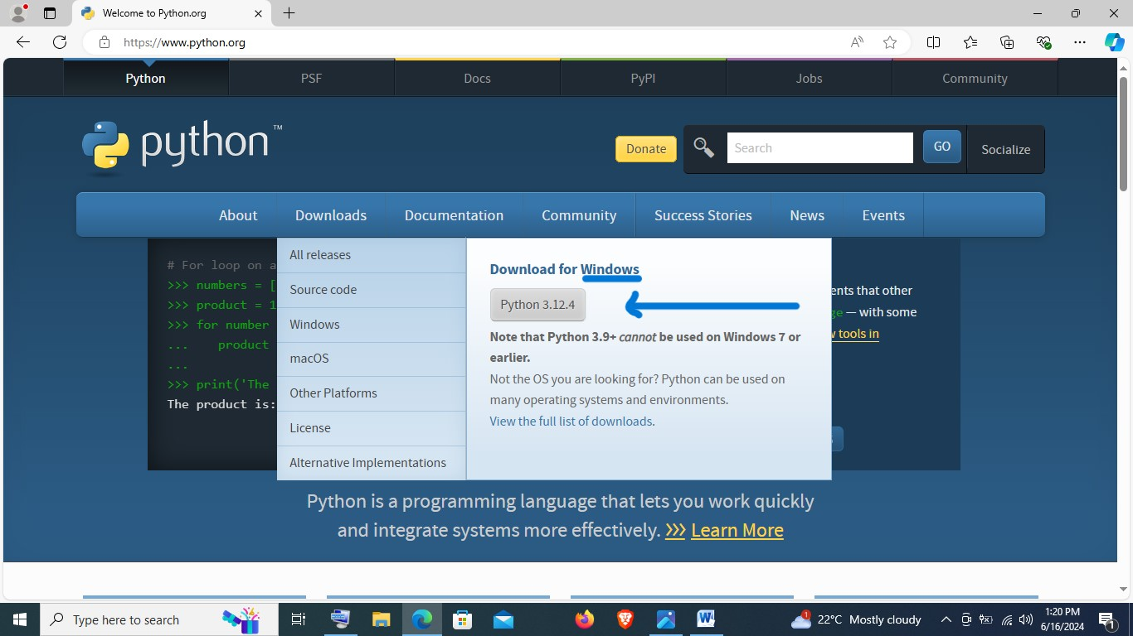

* Once I tap, it initiates an automatic download process.

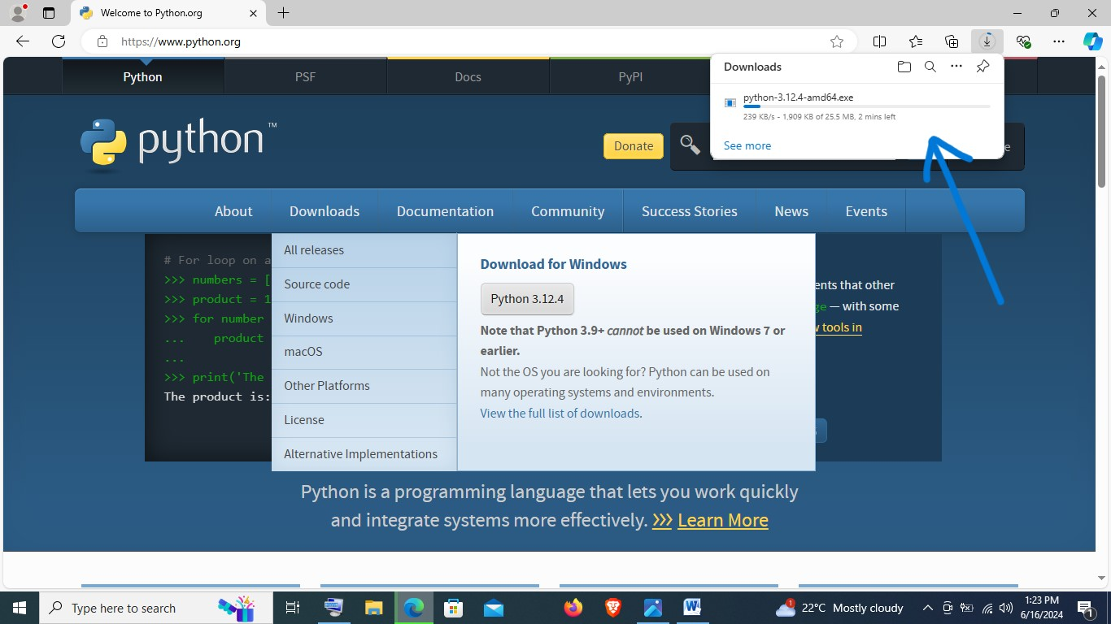

* Open the folder in which the python is downloaded in and right click on the download and choose run as administrator.

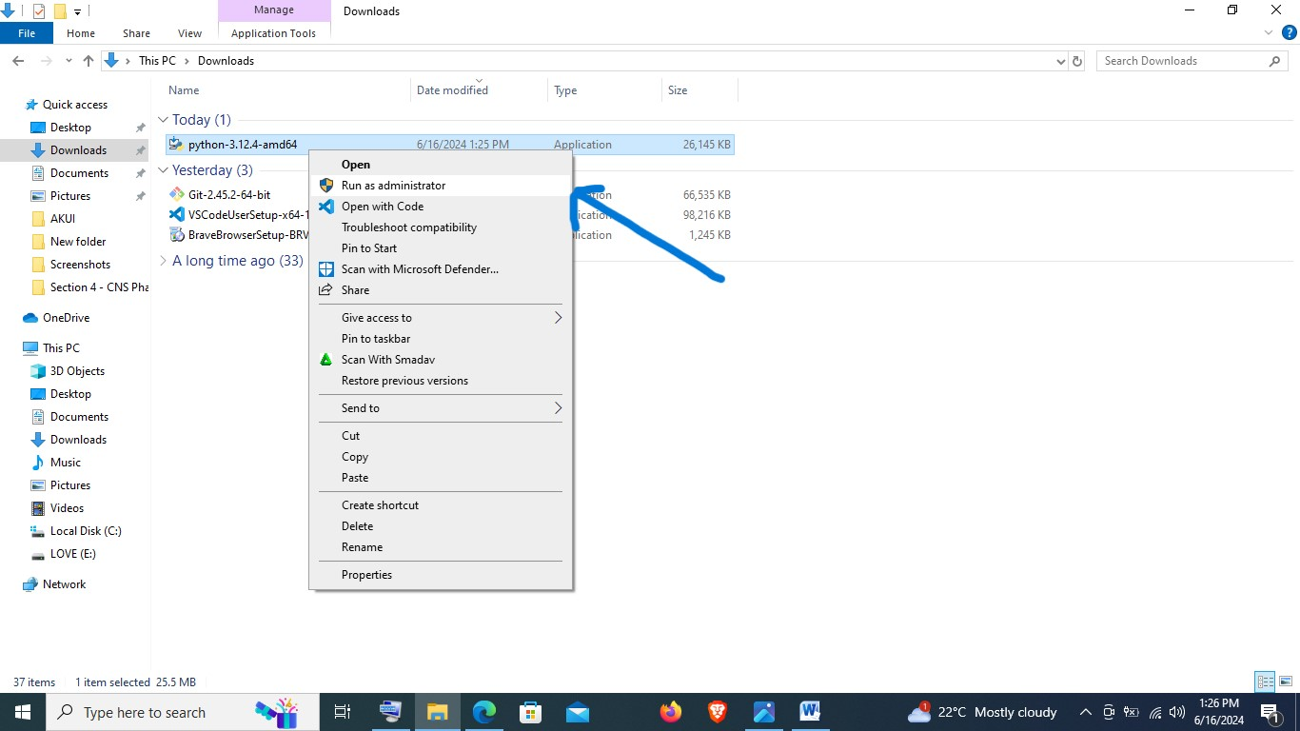

Before initializing the install process, ensure that python is added to path as demonstrated below:

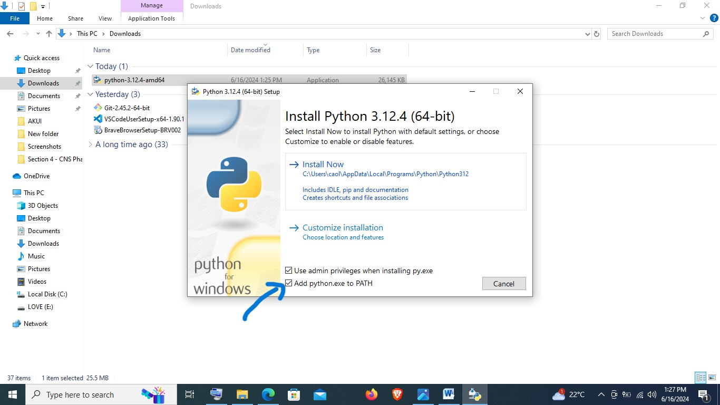

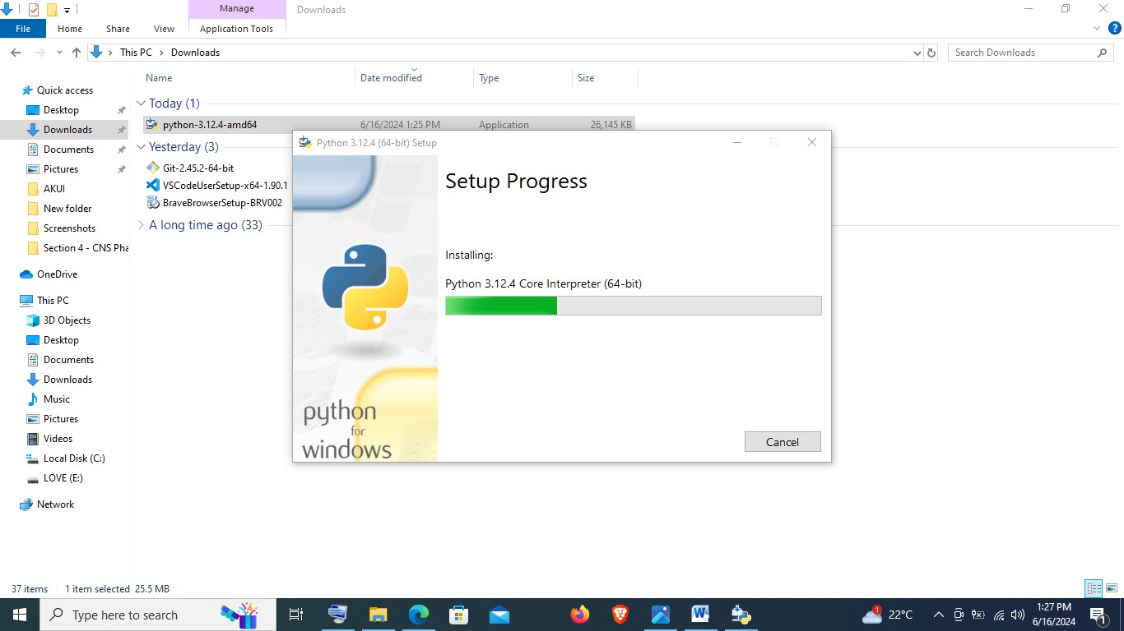

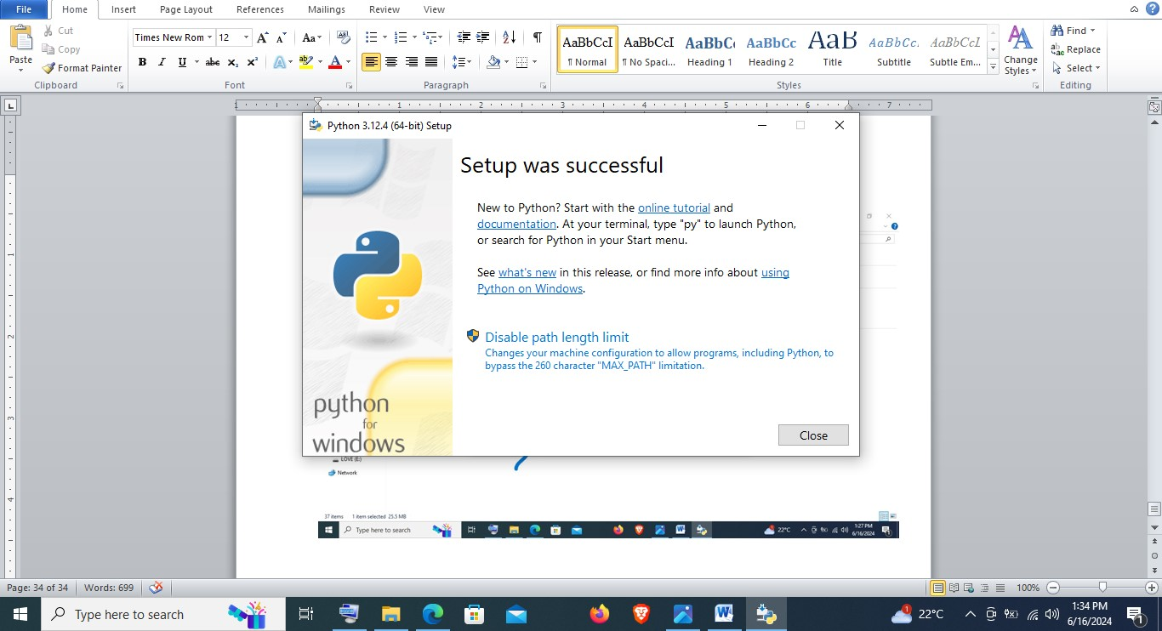

To confirm the install, open python and confirm version, or type python --version on windows command prompt:

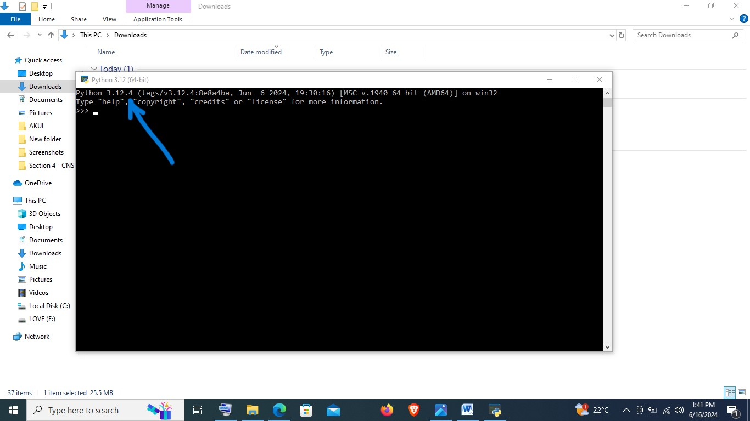

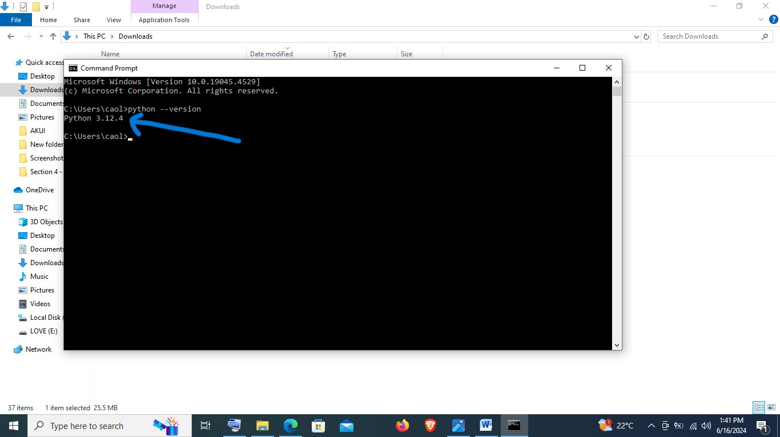

**5. INSTALLING PACKAGE MANAGERS:**

* Before installing pip check if it is already installed, by **typing python -m ensurepip**
* In this case it is already installed given that it is indicated requirement satisfied.

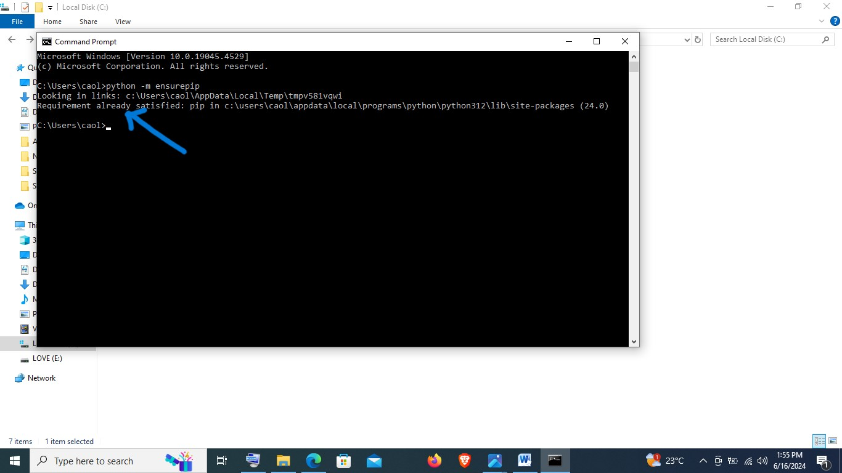

**6. CONFIGURING A DATABASE (MySQL):**

* Open the link: <https://dev.mysql.com/downloads/windows/installer/8.0.37.html> to open the following site and choose my operating system and version to download a compatible MySQL for my laptop.

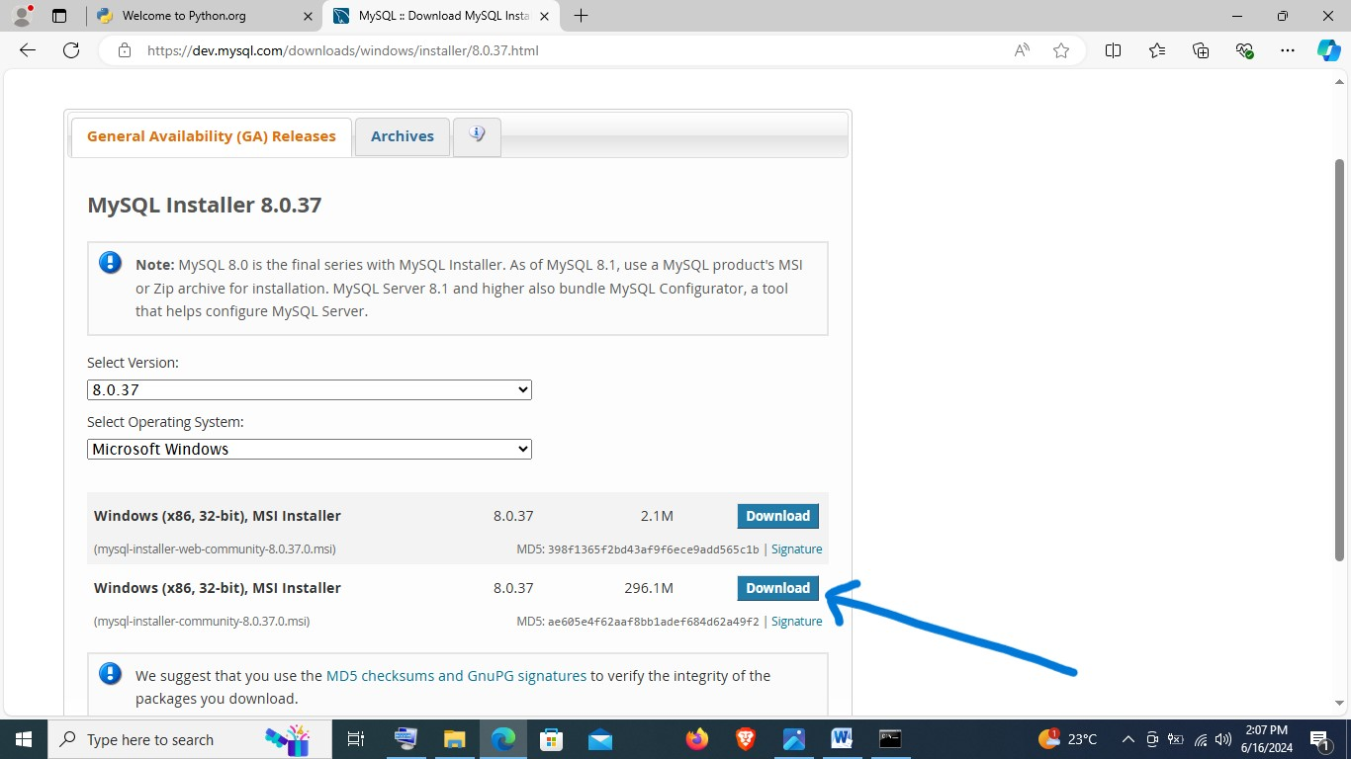

This will lead to the following page, where a download link is clicked on as highlighted below:

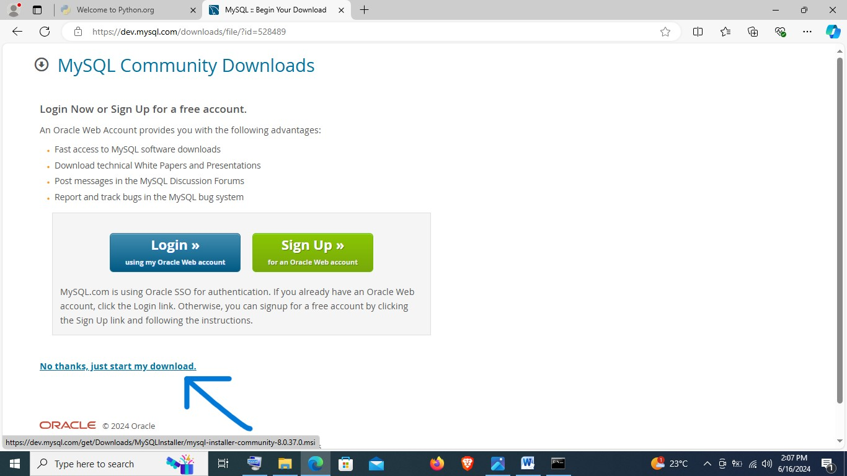

This will prompt installation process:

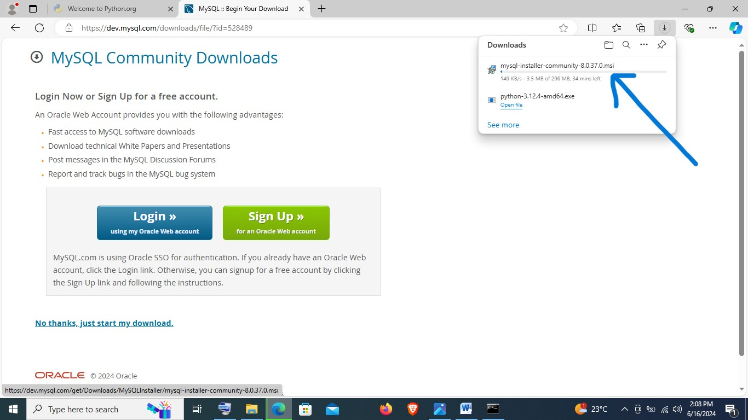

Open the folder in which the python is downloaded in and right click on the download and install:

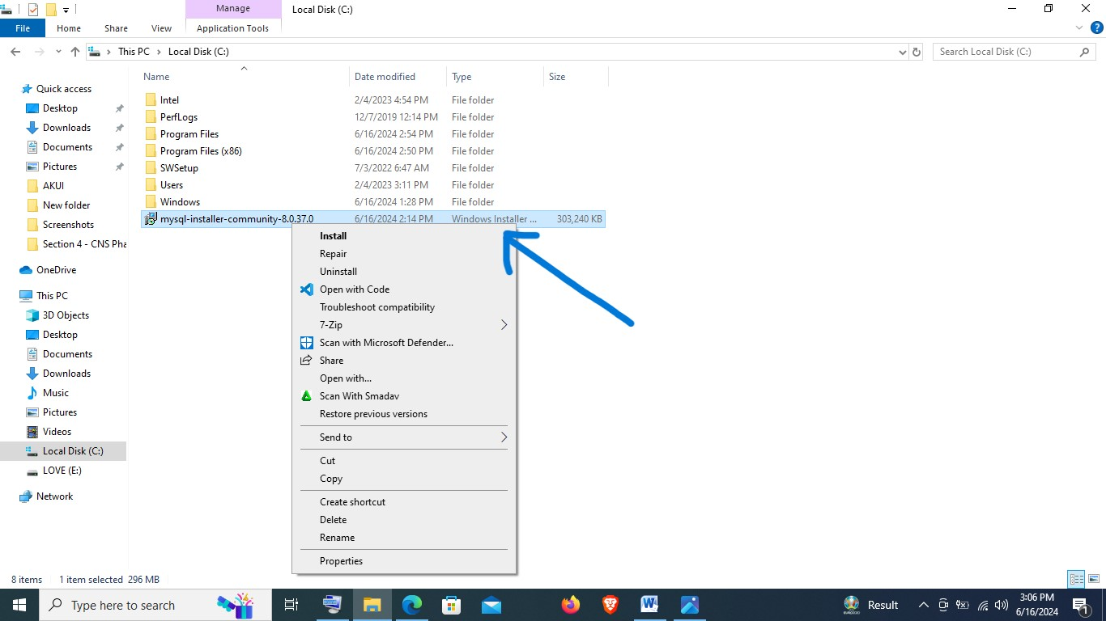

Then the following steps are as highlighted by the following images:

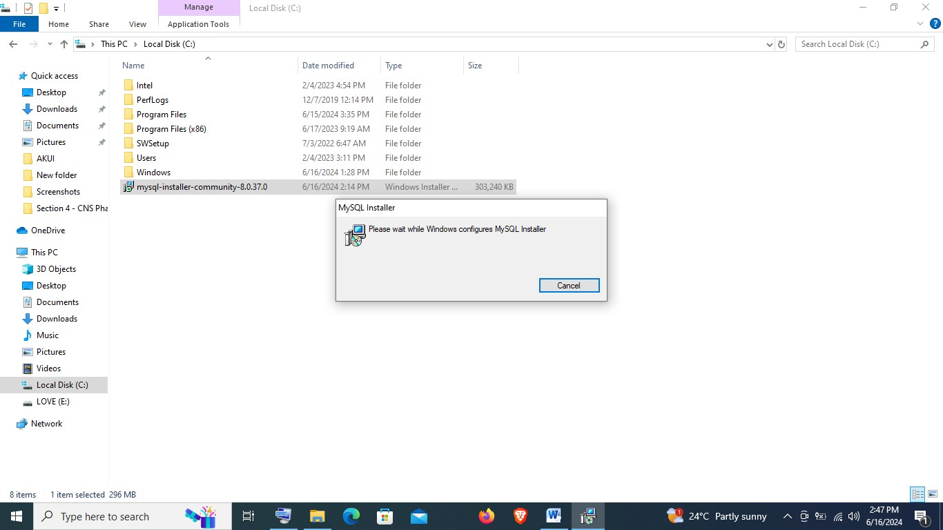

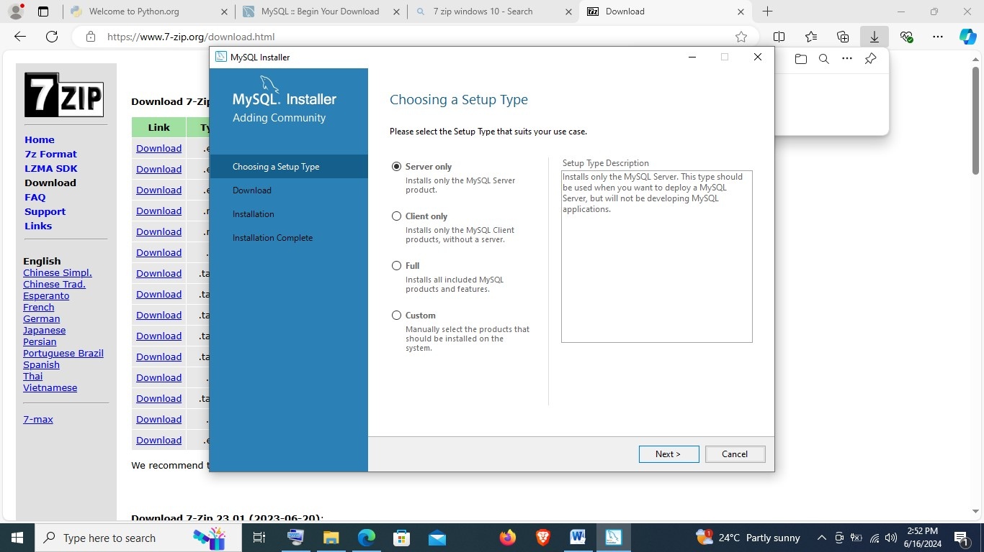

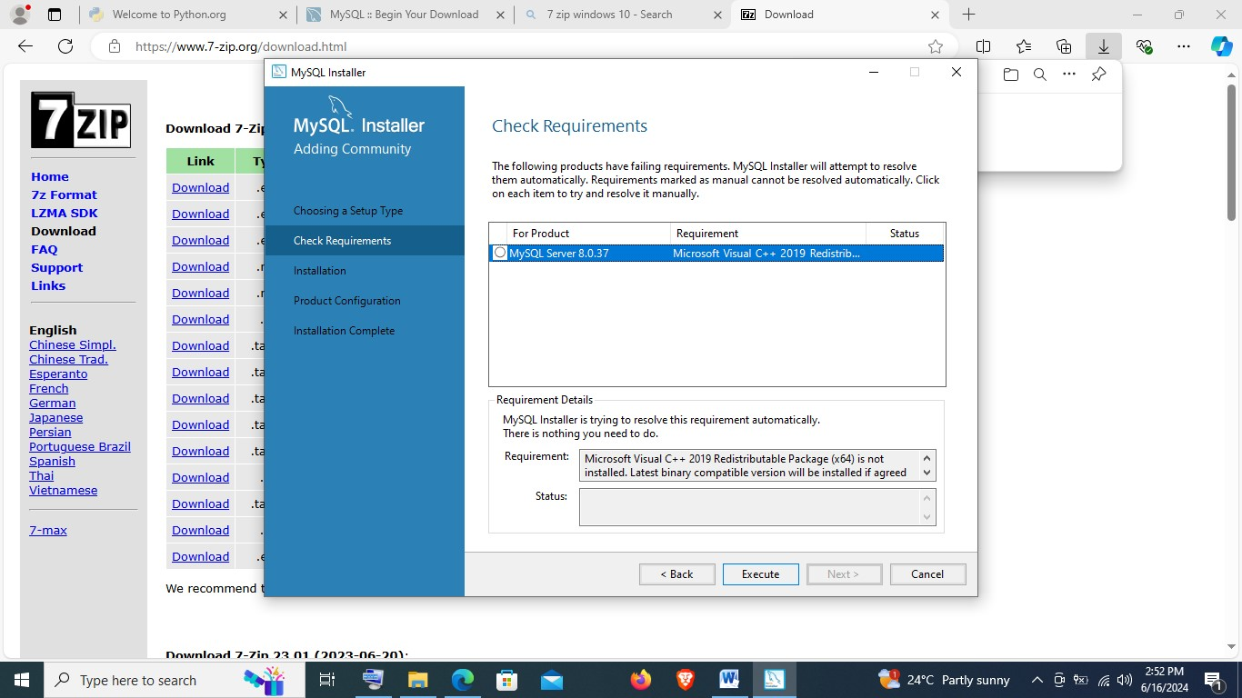

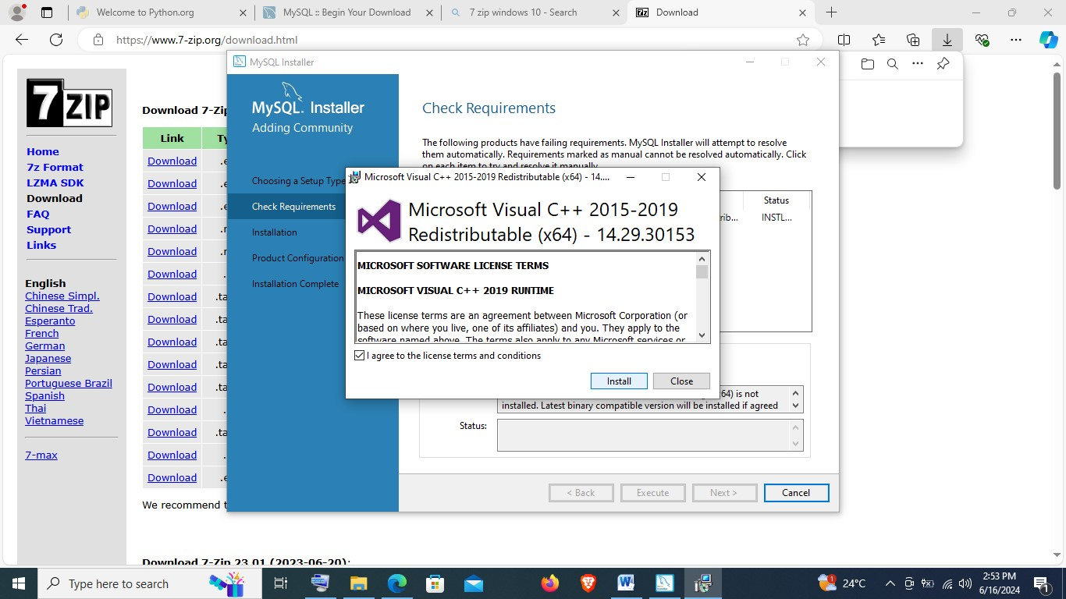

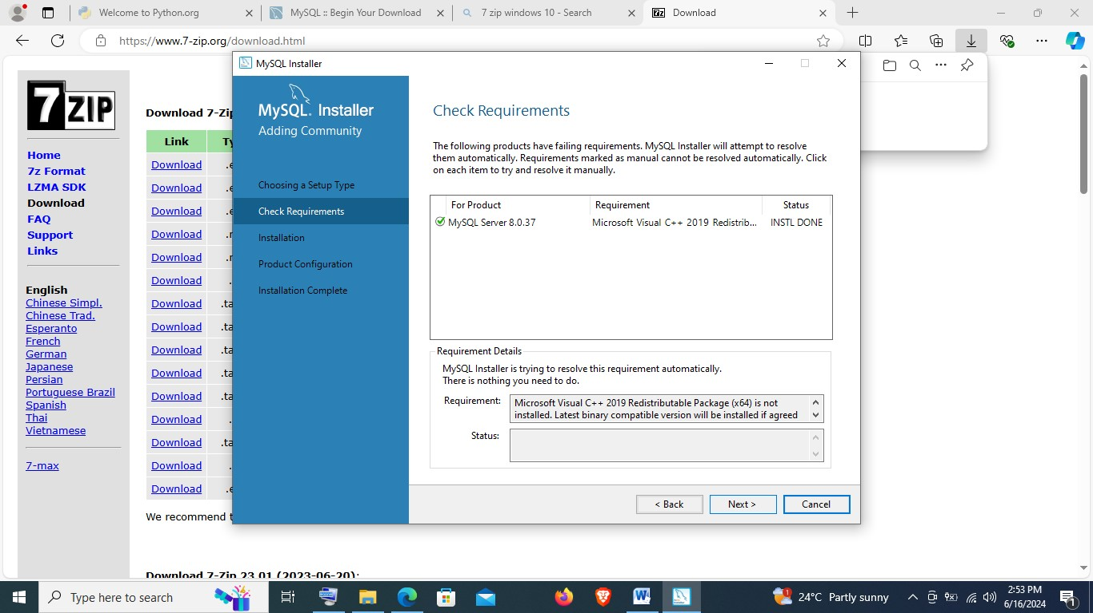

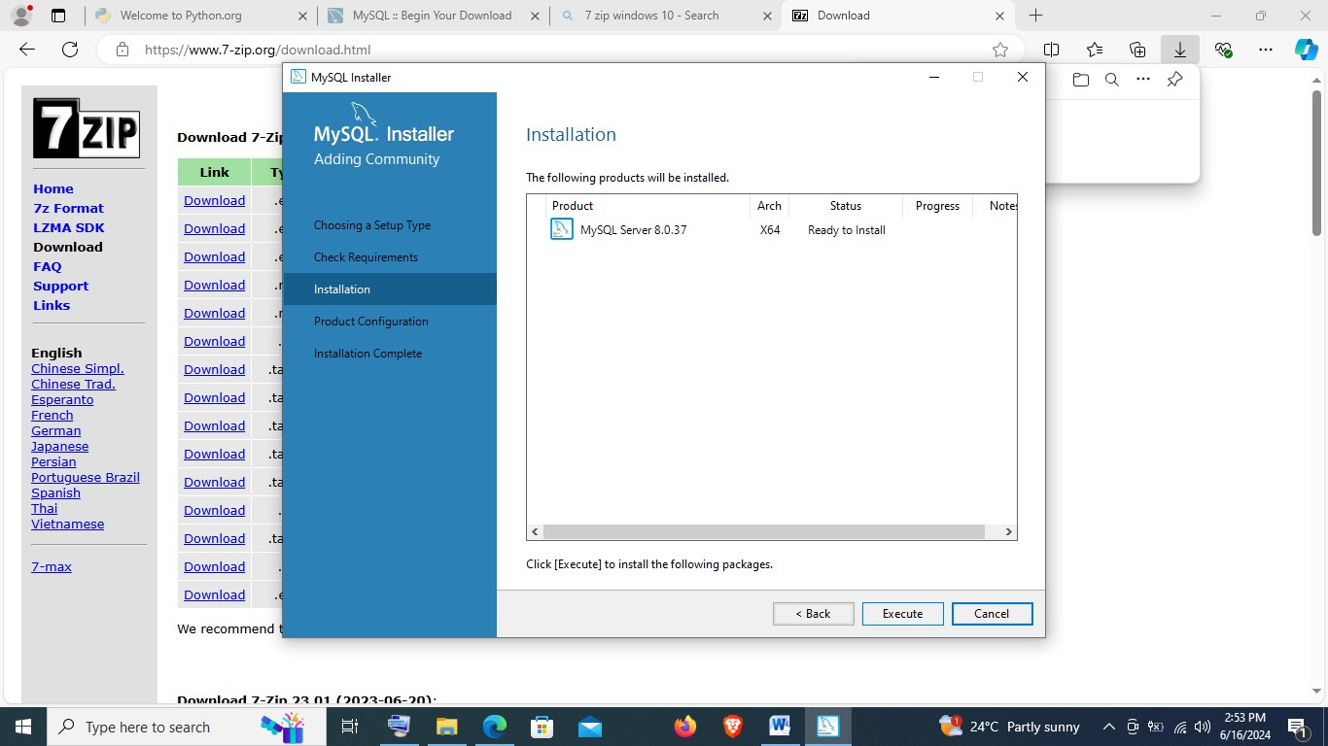

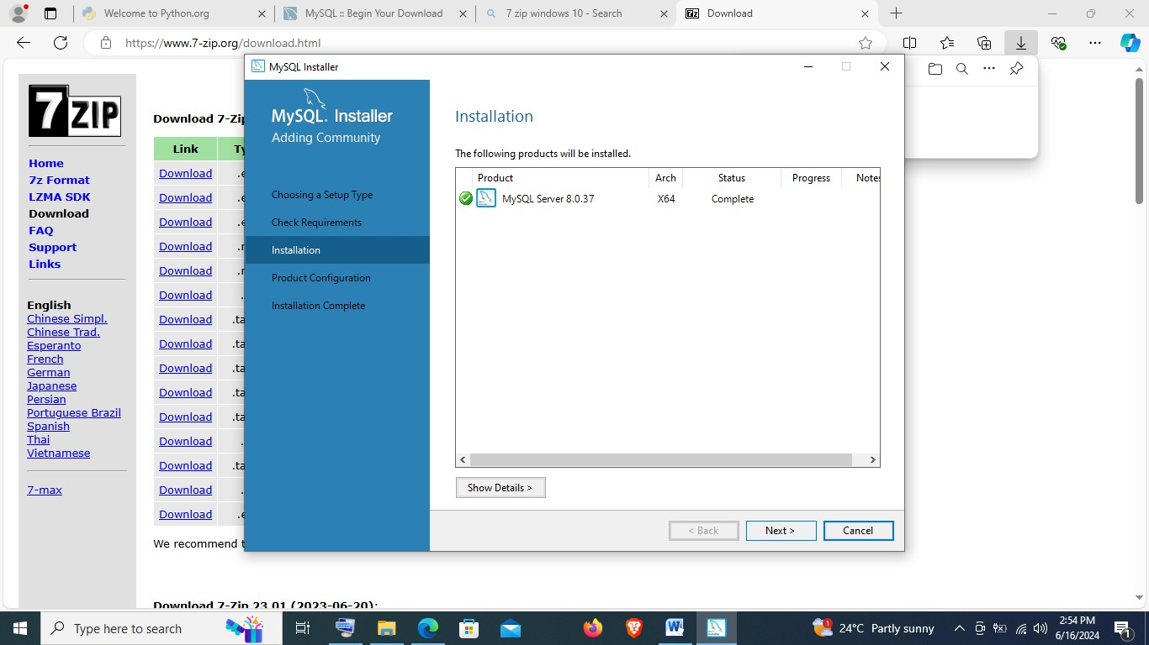

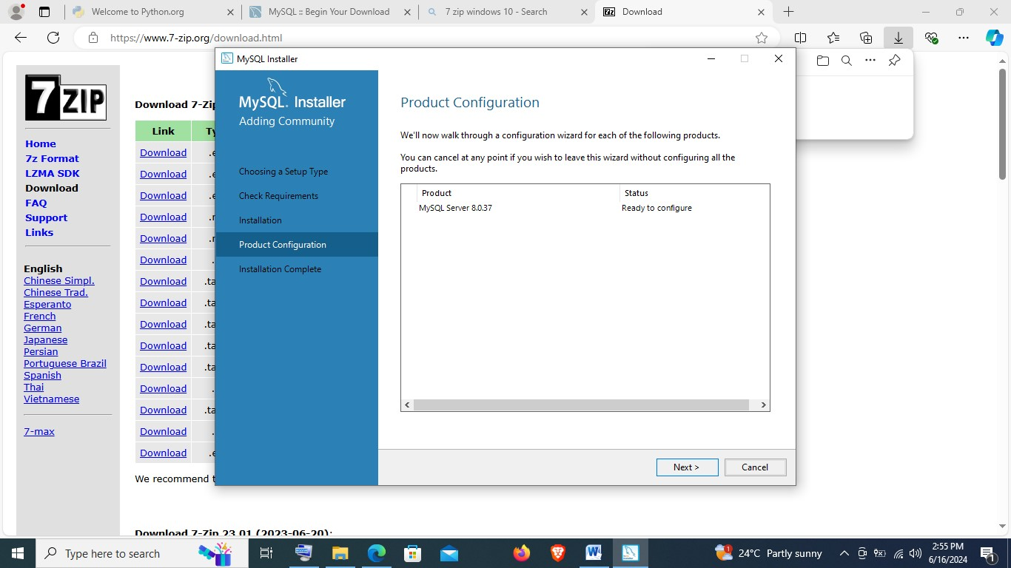

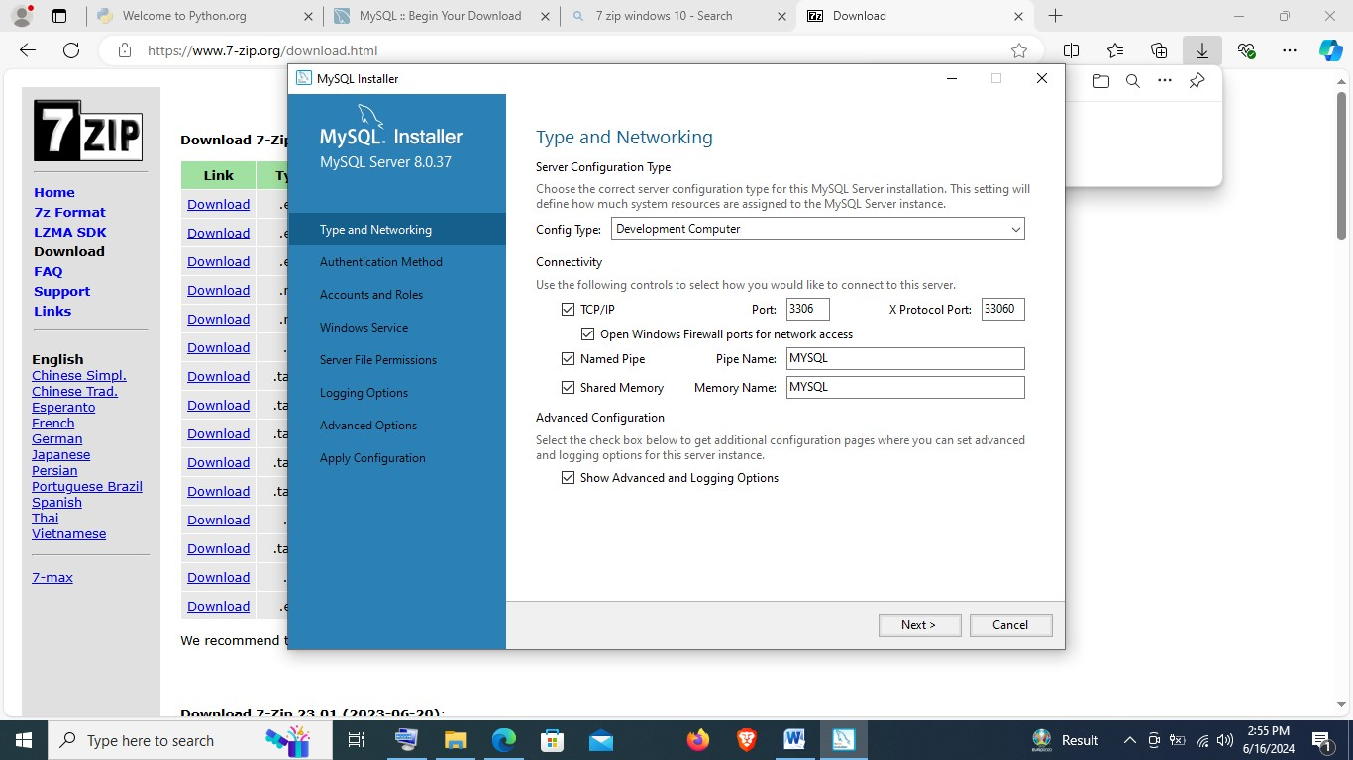

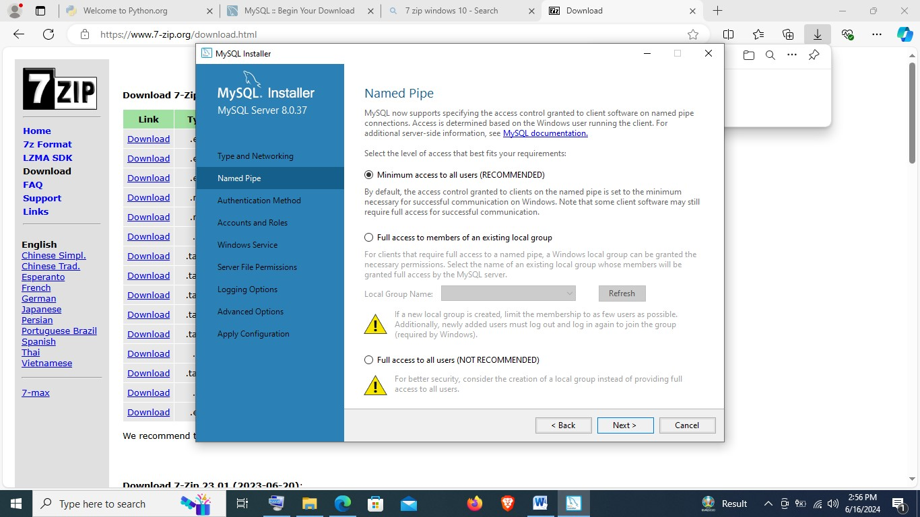

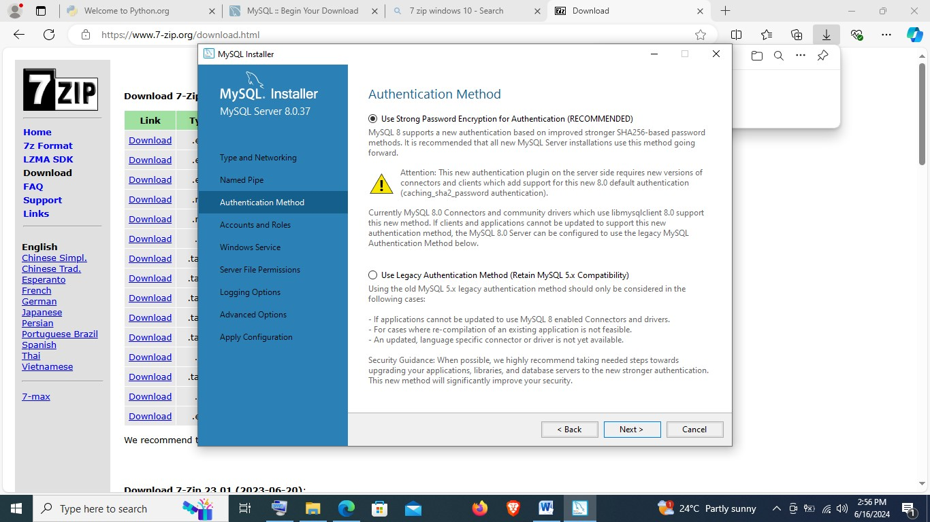

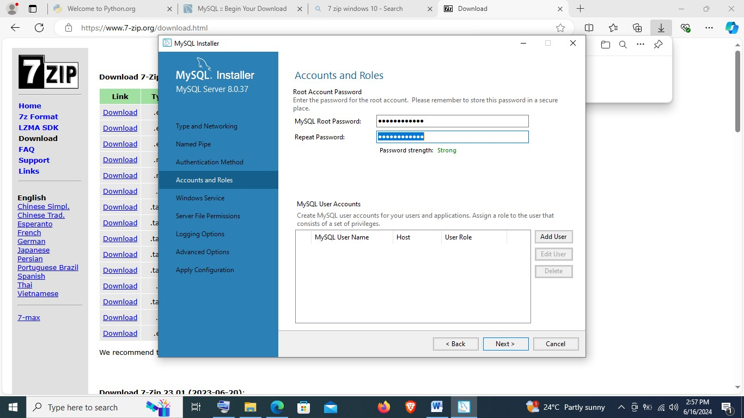

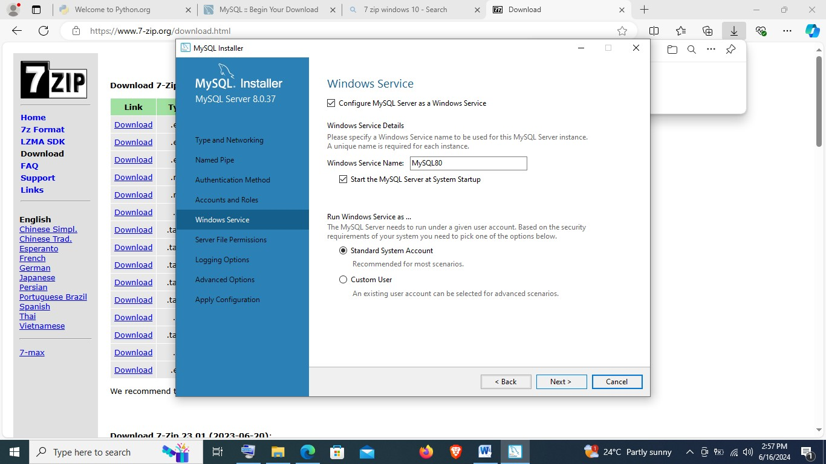

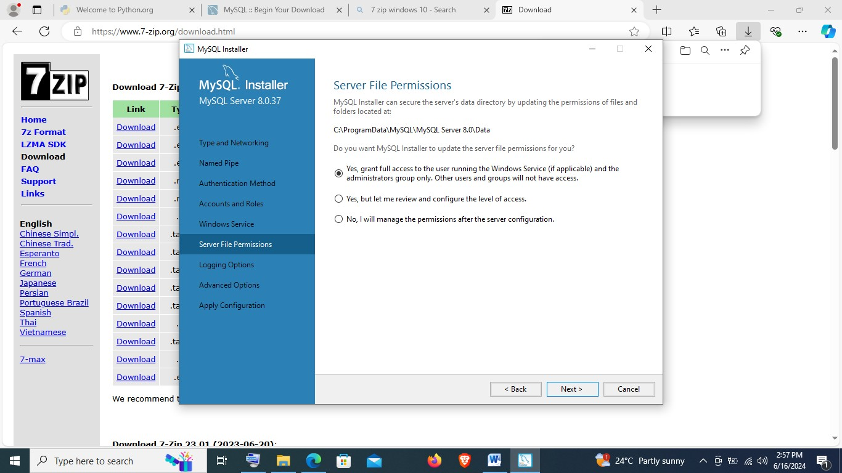

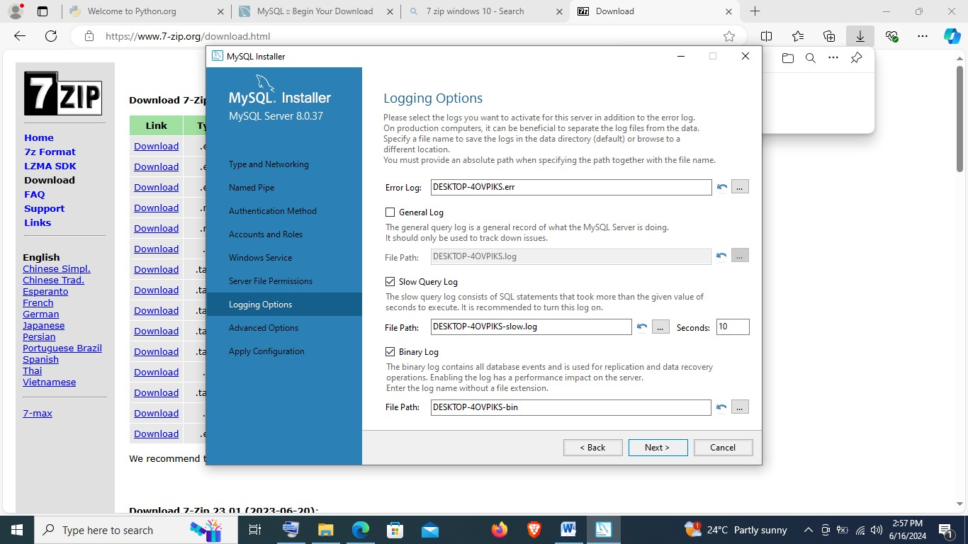

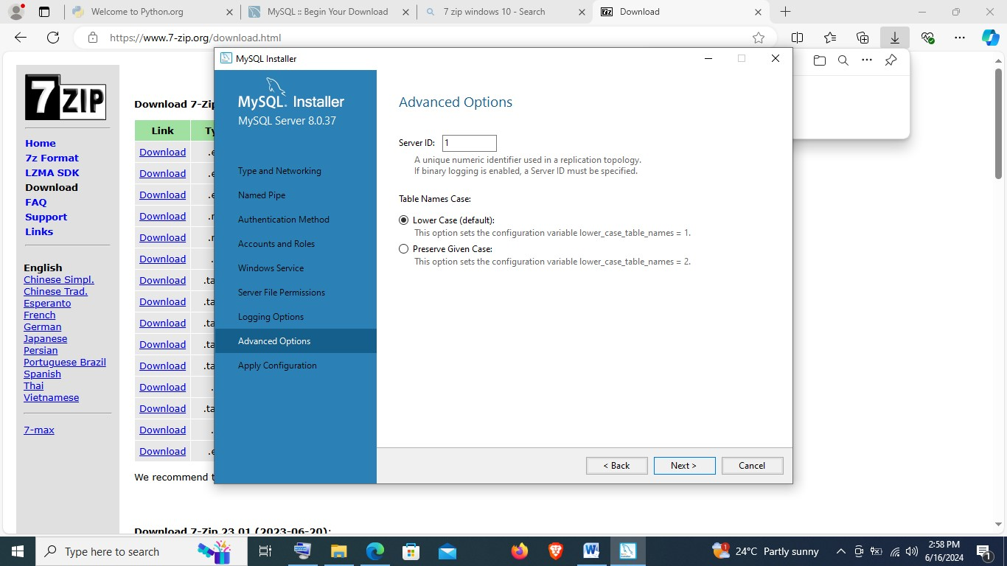

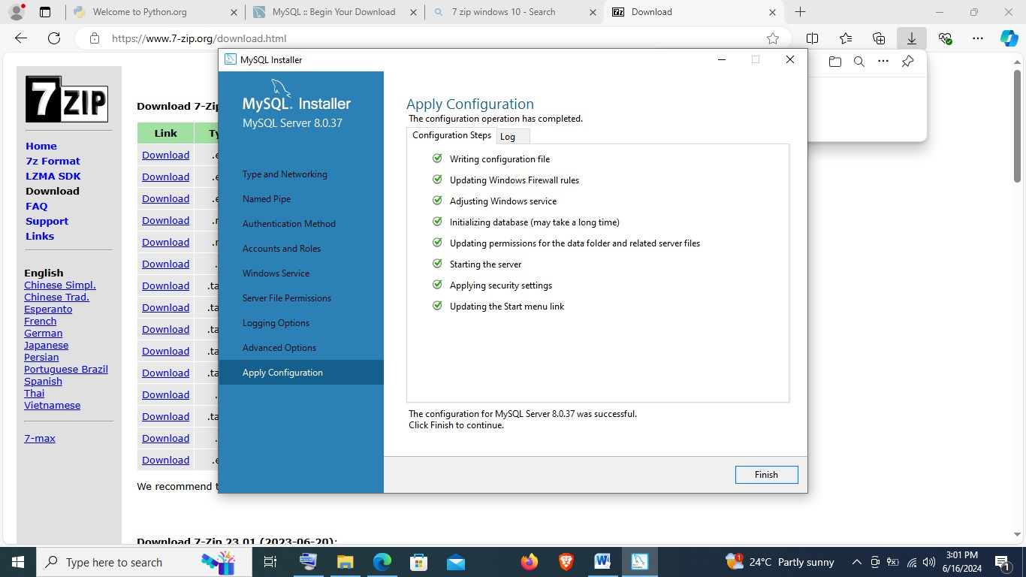

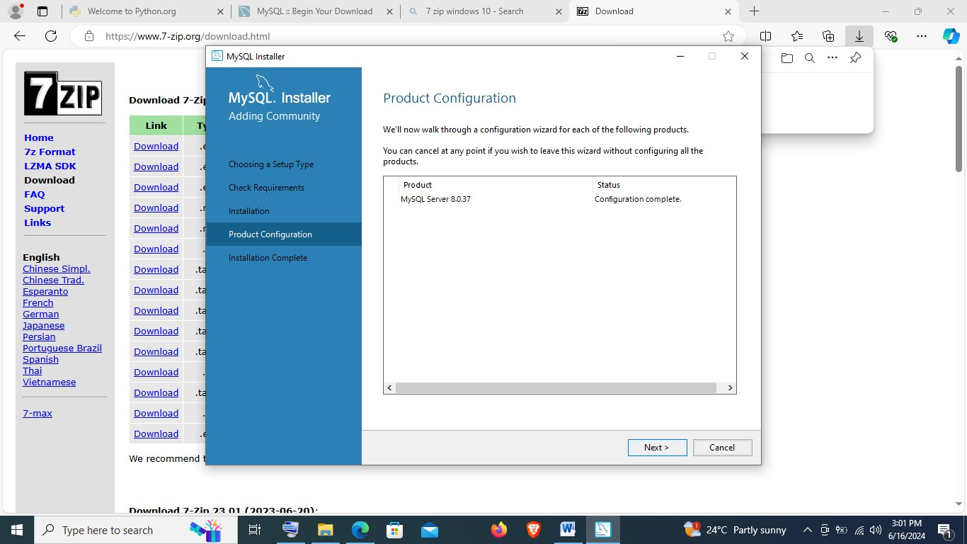

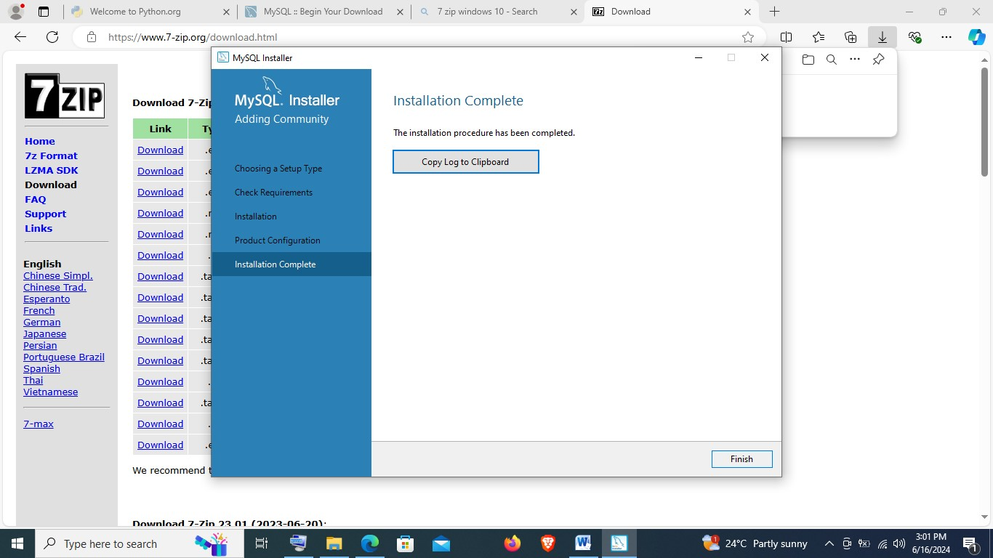

**NB:** to call MySQL from command prompt, **type mysql -u root -p** which will open MySQL prompting for a password.

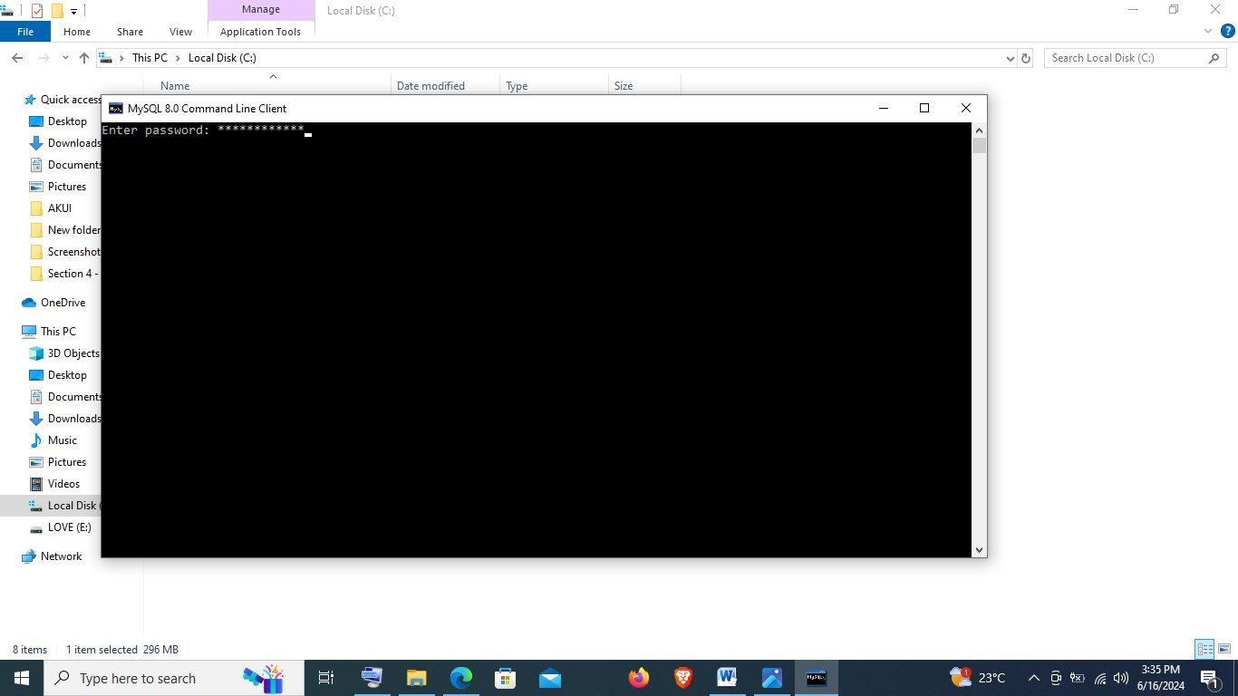

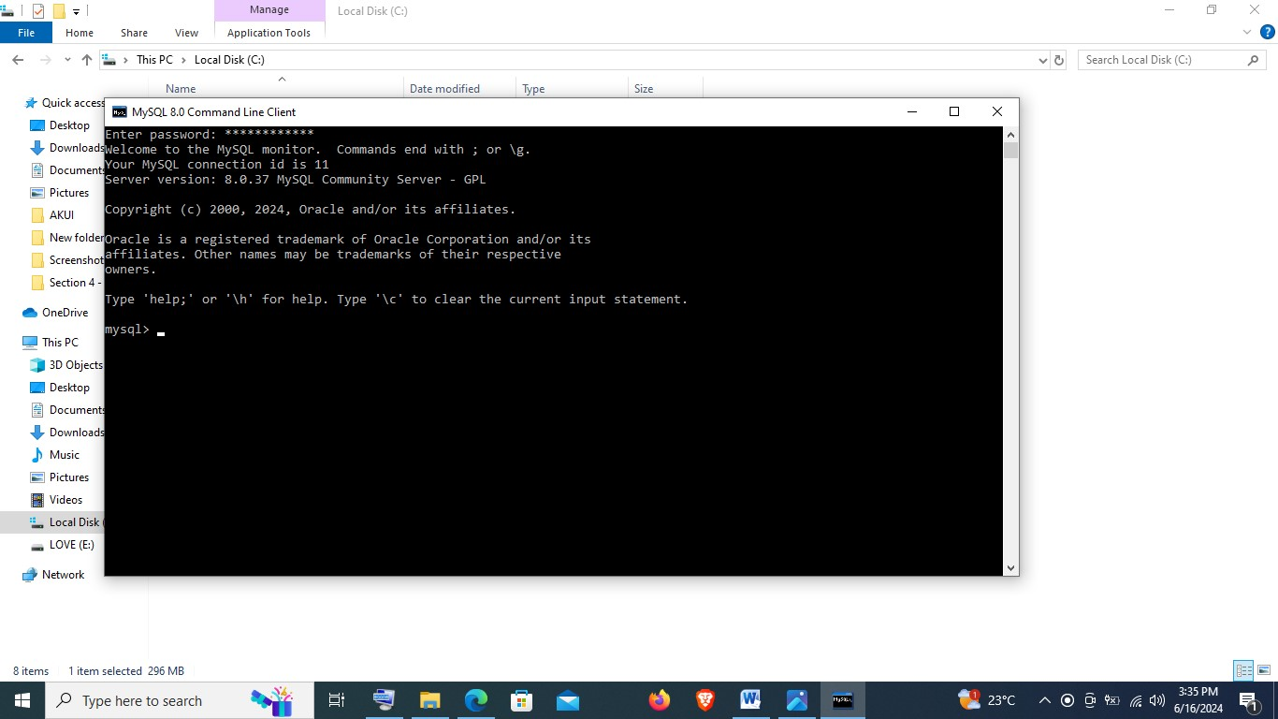

To create database type **CREATE DATABASE PLPACADEMY;**

To show database type **show databases;**

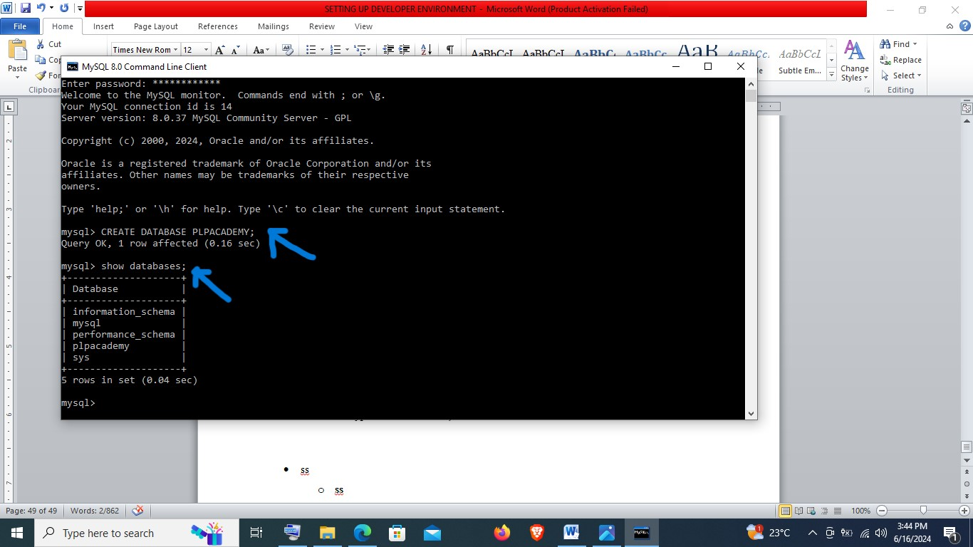

To have a visual view of the database, on the windows search bar type mysql workbench and run as administrator:

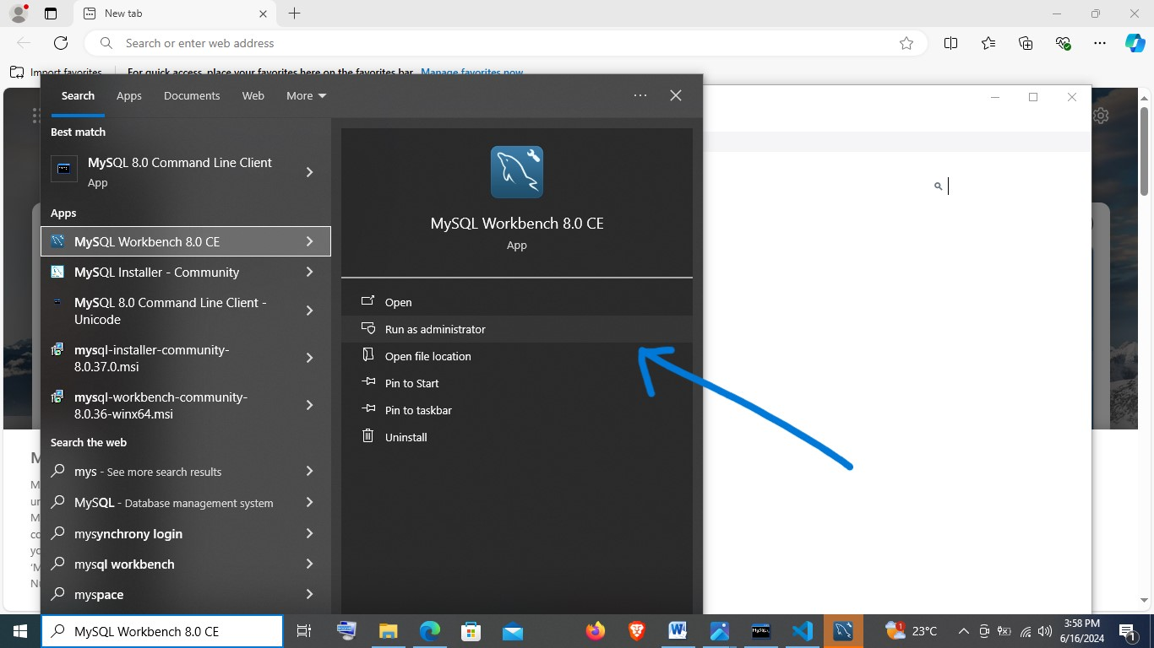

Once it opens, click on the local instance MySQL80, which prompts log in:

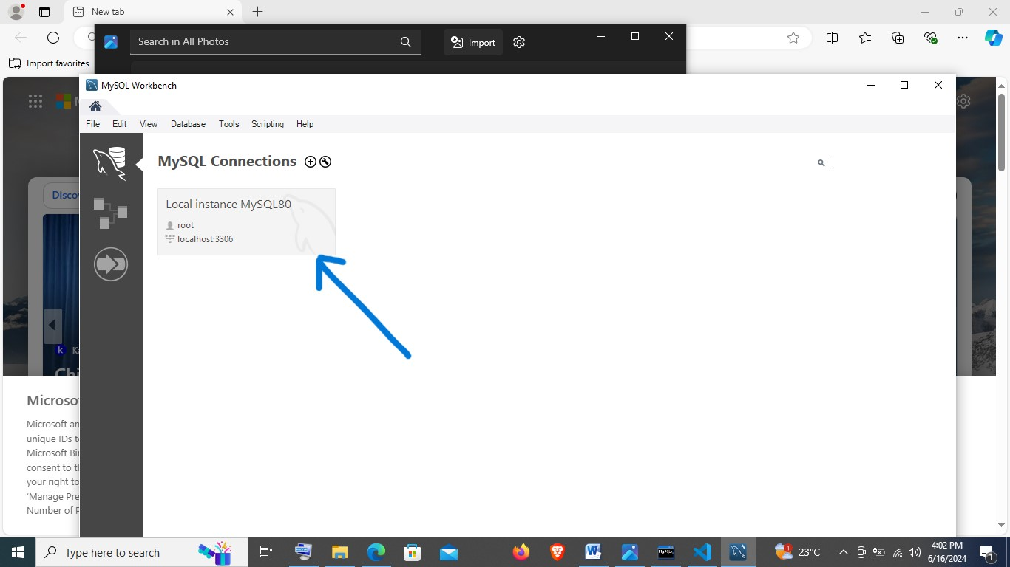

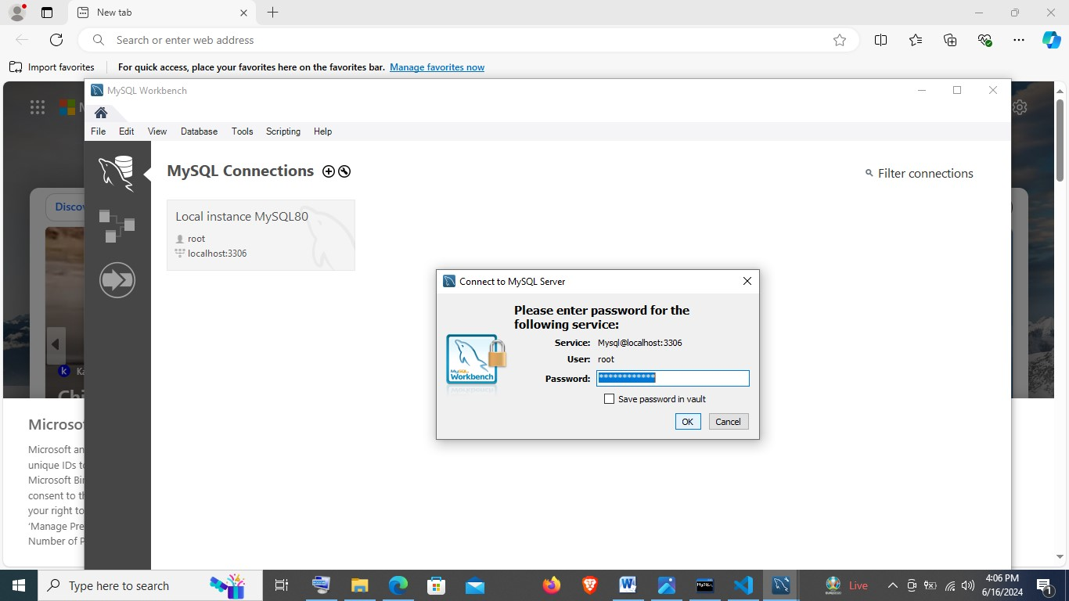

Open schemas:

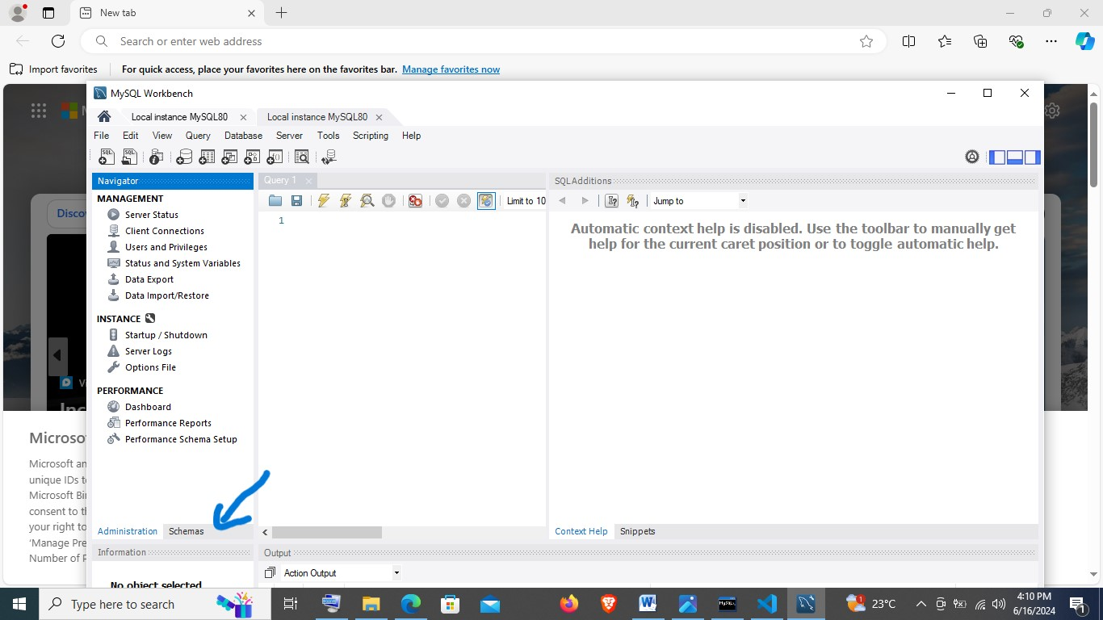

It will open to show databases, one of which is the newly created **PLPACADEMY:**

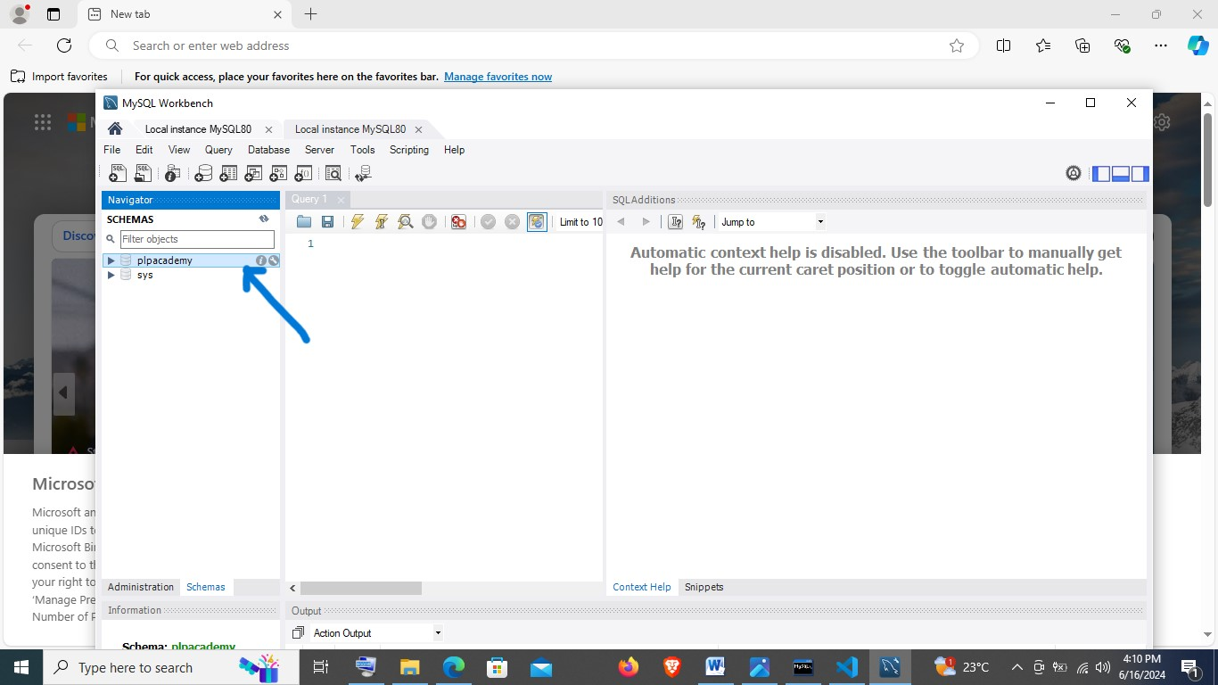

**7. EXPLORING EXTENSIONS AND PLUGINS IN VISUAL STUDIO**

